**PCB PROJECT INTERIM REPORT**

**ABDUL RAHIM BIN SAIDI**

**FACULTY OF ENGINEERING**

**UNIVERSITI MALAYSIA SABAH**

**2019**

**DECLARATION**

I spacing hereby declare that this report, submitted to University Malaysia Sabah as partial fulfilment of the requirements for the degree of Bachelor of Civil Engineering, has not been submitted to any other university for any degree. I also certify that the work described herein is entirely my own, except for quotations and summaries sources which have been duly acknowledged.

This report may be made available within the university library and may be photocopied or loaned to other libraries for the purposes of consultation.

11 November 2019 Abdul Rahim Bin Saidi

CERTIFIED BY

________________________________

Associate Professor Ir. Othman Ahmad

SUPERVISOR

**ABSTRACT**

One of the backbones in electronic manufacturing industry is the printed circuit board (PCB). However, with the recent rapid growth in electronics devices, the production number of the PCBs is also rapidly escalating. For electronic equipment and appliances which are based on PCB, new generations of PCB’s are being produced to suit the requirements of new products. This development can lead to waste and inefficiency when perfectly serviceable electronic components and appliances have to be scrapped because the spare PCBs are no longer available from the Original Equipment Manufacturer (OEM) or are already obsolete. This report proposes a new method for reverse engineering of an obsolete PCB. An equivalent PCB can be produce using this any methods such as utilizing using image processing technique. The methods involve in several steps, such as Data Acquisition, PCB Scanning, Image Processing, Vectorization and CAD Editing, PCB Fabrication, and Circuitry testing and Analysis. Reverse engineering a printed circuit board (PCB) is useful for purposes such as repairing equipment or designing back for which component-level documentation is not available, integrating a poorly-documented board into a system, and for identifying obsolete parts or also can create any PCB design by using the main ESP8266 PCB Board.

## **CONTENTS**

## **Page**

## **DECLARATION ii**

## **ABSTRACT iii**

## **CONTENTS iv**

## **LIST OF TABLES ix**

## **LIST OF FIGURES x**

## **LIST OF SYMBOLS xii**

## **CHAPTER 1 INTRODUCTION 1**

## 1.1 Project Overview 1

## 1.2 Problem Statement 2

## 1.3 Project Purpose 2

## **CHAPTER 2 LITERATURE REVIEW 4**

## **2.1 Introduction 4**

### 2.1.1 Printed Circuit Board (PCB) 4

### 2.1.2 Comparison of Different Microcontroller 5

### 2.1.3 ESP8266EX Microprocessor 7

### 2.1.4 ESP8266 Node MCU Wireless Mode 7

## **2.2 Reason Using ESP8266 8**

### 2.2.1 Cost 8

### 2.2.2 More Compatible Development Environments 8

### 2.2.3 Flexible Design and Enhanced Function 8

### 2.2.4 Learning Resources 9

### 2.2.5 Convenient Application Development 10

### 2.2.6 Incentive Program 10

### **2.3 Different Modules of ESP8266 10**

### **2.4 Arduino Microprocessor 12**

### **2.5 Summary 14**

## **CHAPTER 3 METHODOLOGY 15**

## **3.1 Introduction 15**

## **3.2 Safety and Precaution or Equipment’s on LAB 15**

### 3.2.1 Eye Washer 16

## **3.3 Simulation 17**

### 3.3.1 Installing the Proteus Demo 17 3.3.2 Run the simulation 17

## **3.4 Installing the Additional Component 19**

## **3.5 Soldering Pins ESP-12E 20**

### 3.5.1 Tinning a Pin with or Without Flux 20

### 3.5.2 To Clean and re Tin the Soldering Iron 20

## **3.6 DesignSpark 20**

## 3.6.1 Familiarisation 21

## 3.6.2 Schematics 21

## 3.6.3 Translate to PCB 21

## 3.6.4 Exporting 21

## 3.6.5 Libraries 21

## 3.6.6 Creating Components 22

## 3.6.7 Adding Cooper Pour to DesignSpark 22

# **3.7 Ohmmeter and Voltmeter 22**

### 3.7.1 Ohmmeter Reading 22

### 3.7.2 Voltmeter Reading 23

### 3.7.3 Precautions Steps 24

## **3.8 Design Own PCB Board using DesignSpark 24**

### 3.8.1 PCB Design 26

#### 3.8.1.1 Solder Mask 26

#### 3.8.1.2 Adding Text on the Top Silkscreen of Board 28

#### 3.8.1.3 Difference Between Solder Mask and Paste Mask 28

## **3.9 Process Circuit of Printed Wiring Board 28**

### 3.9.1 Mask 29

### 3.9.2 Etching 32

### 3.9.3 Drilling 34

### 3.9.4 Precaution Steps 35

## **CHAPTER 4 OBSERVATION AND RESULT 36**

## **4.1 Introduction 36**

## **4.2 Tinning Pin 36**

### 4.2.1 Observation 36

### 4.2.2 Design 37

### 4.2.3 Characteristic Design 37

## **4.3 Multimeters 37**

### 4.3.1 Results 37

### 4.3.2 Analysis 38

### 4.3.3 Error 38

## **4.4 Re-Design ESP-12S to ESP-12E 38**

## **4.5 PCB Final Project Result 39**

## **CHAPTER 5 ANALYSIS OF RESULT AND GENERAL DISCUSSION 40**

## **5.1 Introduction 40**

## **5.2 Analysis of the Result 40**

### 5.2.1 Error during Process of Circuit on Printed Wired Board 40

### 5.2.2 Impact of the Error 40

## **5.3 General Discussion 41**

### 5.3.1 Software 41

### 5.3.2 Schematics 42

### 5.3.3 Library 44

## **5.3.4 Problem Occur 44**

## **5.3.5 PCBWay 45**

## **CHAPTER 6 CONCLUSIONS AND RECOMENDDATIONS 46**

## **6.1 Conclusions 46**

## **6.2 Recommendations 46**

## **REFERENCES 49**

**LIST OF TABLES**

Table No. Page

Table 2.0 Various Microcontrollers with Loaders and Comparing Their Characteristic 5

Table 2.1 Comparison and Characteristic ESP8266 Modules 10

Table 2.2 Comparison Between Arduino Microprocessor 12

Table 4.0 Ohmmeter Reading 15

Table 4.1 Voltmeter Reading 16

**LIST OF FIGURES**

Figure No. Page

Figure 1.0 ESP8266 PCB Board 3

Figure 2.0 A Printed Circuit Board Integrates Components and Conductors 5

Figure 2.1 ESP8266 Wi-Fi Module 8

Figure 2.2 Different Design and Modules ESP8266 9

Figure 2.3 Books about ESP8266 9

Figure 2.4 Various Application Development 10

Figure 3.0 Equipment’s that Should to be Wear on LAB 15

Figure 3.1 Safety and Warning Signs 16

Figure 3.2 Using the Eye Washer Equipment 16

Figure 3.3 Proteus Demo 17

Figure 3.4 The Result by Running the LED Blink 18

Figure 3.5 Simulation of ESP8266 18

Figure 3.6 SamacSys Library Loader 19

Figure 3.7 Tinning Pin using Soldering Iron and Solder 20

Figure 3.8 Schematic Design ESP8266-12S 21

Figure 3.9 Taking Ohmmeter Reading 22

Figure 3.10 USB Connected to PCB Connector 23

Figure 3.11 Taking Voltmeter Reading 23

Figure 3.12 Checking Short Circuit 24

Figure 3.13 Schematics Design own PCB Project 25

Figure 3.14 The Project Design after Connected the Wires, Components, Adding Cooper 25

Figure 3.15 Step Layers Option 26

Figure 3.16 Step Down Option 27

Figure 3.17 Step Choose Layer Option 27

Figure 3.18 Adding Text Silkscreen 28

Figure 3.19 Cutting the PCB Board 29

Figure 3.20 Clean the PCB Board with Sand Paper 29

Figure 3.21 PCB Board Wrapped with the Printed PCB Design on Glossy Paper 30

Figure 3.22 PDF PCB Design Printed on Glossy Paper 30

Figure 3.23 Printed PCB Design been Ironed to Board 31

Figure 3.24 Wrapped Ironed PCB Board Fully Soaked to Water 31

Figure 3.25 The Design Line on PCB Board Cleared from Dirt 32

Figure 3.26 The PCB Board Soaked into Acid for 10 minutes 33

Figure 3.27 Drilling the PCB Board 34

Figure 3.28 Clear the PCB Board using Sand Paper after Drilling 35

Figure 4.0 Tinned Pins 36

Figure 4.1 Schematic Design ESP-12E 38

Figure 4.2 After Etching 39

Figure 4.3 The PCB Design and The PCB Final Result Project Board 39

Figure 5.0 Arduino Coding Scheme 41

Figure 5.1 Proteus Software 42

Figure 5.2 A Circuit Diagram Behind a Circuit Board 43

Figure 5.3 SamacSys Library Loader 44

Figure 5.4 PCBWay 45

**LIST OF SYMBOLS**

Ω Ohm

**CHAPTER 1**

**INTRODUCTION**

**1.1 Project Overview**

The designers are key personnel in the development of a new electronic product but they are not the only ones. A successful product depends on an intimate co-operation between specialists from many fields. Their common goal is to make a product with the right quality at the right price.

General circuit design is the scope of this report. We shall discuss those aspects of the design connected the choice of technology, components, PWB layout and production on PCB circuit level. The design is generally performed on a CAD system. After entering the netlist and the components, the circuit diagram is worked out. Information and symbols for each component are stored in the CAD system component library. Instead of experimenting with hardware models more and more are done by computer simulations, as the circuit complexity and speed of operation increases.

The layout or PWB design is simplified by more or less automatic routing performed by the CAD system. Still, critical information about placement of certain components, electromagnetic compatibility (EMC), thermal limitations, etc is manually entered by the designer. From the CAD system we get the schematic, assembly drawings and other documentation, data for photo- or laser plotter to manufacture photographic films for the PWB production, data for the printing mask for solder resist and solder paste printing, data for numeric drilling and milling machines, placement information for pick and place machines, data for test fixtures and the testing machine, etc.

By using the correct method on using the testing and fabrication equipment, the designer can complete the design and built electronic circuits on PCB aided by CAD successfully without any problem.

**1.2 Problem Statement**

Going through Industry 4.0 in Malaysia, since there were a lot of design built in PCB board with different purpose by the designer but some of it have a lot of disadvantages, this project will take the lead to solve the problem occurred.

There are some projects that less handy for some people, the quality is not very satisfying and some of it are rarely working meaning that the project is only half successfully done. The process for the failures or breakdowns needs more time to resolve which is the main part of this project.

**1.3 Project Purpose**

For this project, the ESP8266 PCB board have been use to design the PCB board. ESP8266 is gaining popularity in the field of electronics because of its low-cost, reliability and easily availability in the market. People from various countries have formed an ESP8266 community forum, which gives necessary details about programming and other related issues concerning this module.

ESP8266 contains a built-in 32-bit low-power CPU, ROM and RAM. It is a complete and self-contained Wi-Fi network solution that can carry software applications as a stand-alone device or connected with a microcontroller (MCU). The module has built-in AT Command firmware to be used with any MCU via COM port. Let’s look at some ESP8266 projects now.

ESP8266 have been use such in bigger project such as Wireless Web Server, World’s Smallest IoT, Pressure Sensor on Railway Tracks, Air Pollution Meter, Humidity and Temperature Monitoring, Wi-fi Controlled Robot, etc. By using the ESP8266, the designer can build any project which approve the requirement and the specification of the ESP8266 PCB board.

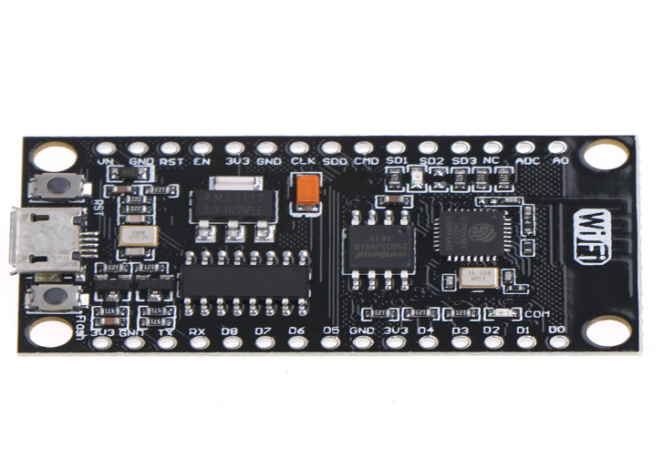

**Figure 1.0 ESP8266 PCB Board**

Source: http://smart2.ums.edu.my/mod/resource/view.php?id=204545

**CHAPTER 2**

**LITERATURE REVIEW**

**2.1 Introduction**

The chapter will cover some of information of ESP8266 and the various or versions modules of ESP8266. This chapter is used for observation of this project.

**2.1.1 Printed Circuit Board (PCB)**

A printed circuit board is an electrical circuit whose components and conductors are contained within a mechanical structure. Conductive features include copper traces, pads, heat sinks, or conductive planes. The mechanical structure is made with insulating material laminated between layers of conductive material. The overall structure is plated and covered with nonconductive solder mask and silk screen to legend electronic component location.

The printed circuit board is built by alternating layers of conductive copper with layers of nonconductive insulation material. During manufacture the inner copper layers are etched leaving intended traces of copper to connect circuit components. Once etched insulation material is laminated to the copper layers and so on until the printed circuit board is complete.

Components are added to the outer layers of the printed circuit board when all the layers have been etched and laminated together. Surface mount parts are automatically applied with robots and through-hole parts are manually placed. All the pieces are then soldered onto the board using techniques such as reflow or wave soldering. The final assembly is plated after which solder mask and silk screen leg ending is applied.

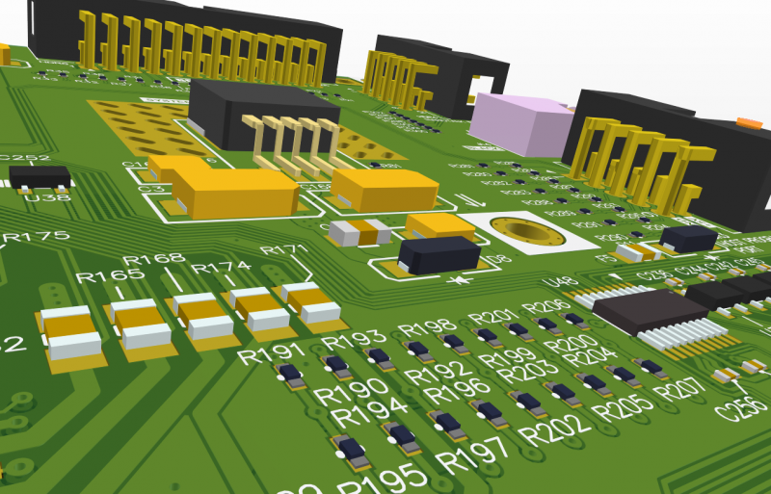

**Figure 2.0 A Printed Circuit Board Integrates Components and Conductors**

Source: https://www.altium.com/solution/what-is-a-pcb/

**2.1.2 Comparison of Different Microcontroller**

ESP8266 itself comes in various forms. ESP-1 is the ESP8266 with only one pin available so is very small. ESP-12E has more pins available to users. ESP8266 is the only microcontroller that has a built-in WIFI circuitry and TCP/IP software. Choosing the right microcontroller can be a hard task to do. In 2.1.1, a table contains various microcontrollers with loaders are compared. Meanwhile in table 2.1.2, various type of Arduino microprocessors’ characteristic is compared. The deciding factor each project will use comes down to two basic things: hardware and cost. While the cost aspect of each Arduino is obvious (the lowest cost option is always the preference), the hardware may not be so easy to determine. When looking at hardware the following should be considered, such as physical dimensions, memory size, analogue input/output and connectivity.

**Table 2.0 Various Microcontrollers with Loaders and Comparing Their Characteristics.**

|  |  |  |  |  |  |  |  |  |  |  |  |  |  |  |  |  |
| --- | --- | --- | --- | --- | --- | --- | --- | --- | --- | --- | --- | --- | --- | --- | --- | --- |
| **Name** | **CPU** | **BITS** | | **MHZ** | | **RAM** | | **FLASH** | | **WIFI** | | **PRIZE** | **SOURCE** | | **COMMENT** | |
| **Picaxe-08M2** |  | 28 | 32 | | 128 | |  | | x | | 9.78 | |  | -Kind of expensive  -Small but perfectly formed | |
| **Arduino 101** | Intel® Curie™ module two tiny cores, an x86 (Quark SE) and an ARC | 32 | 32 | | 2400 | | 186 | | x | |  | | Wikipedia |  | |
| **Arduino**  **Due** | ATSAM3X8E(Cortex-M3) |  | 84 | |  | |  | | x | |  | |  |  | |
| **Picaxe-40x2** |  | 56 | 64 | | 1280 | | 32 | | x | | 29.20 | |  | Big but comes with higher capabilities | |
| **Arduino Micro** | ATmega32U4 |  | 16 | |  | | 32 | | x | |  | |  |  | |
| **Arduino MKR1000** | ATSAMW25 | 32 | 48 | | 3200b | | 256kb | | WINC1500 low power 2.4GHz IEEE® 802.11 b/g/n Wi-Fi | | 215.00 | | wiki | MKR1000 runs at 3.3V  Applying voltages higher than 3.3V to any I/O pin could damage the board. | |
| **Arduino/Genuino** |  |  | 48 | |  | | 32 | | x | |  | |  |  | |

**2.1.3 ESP8266EX Microprocessor**

ESP8266EX or also known as ESP8266 is a system-on-chip (SoC) which integrates a 32-bit Ten silica microcontroller, standard digital peripheral interfaces, antenna switches, RF balun, power amplifier, low noise receive amplifier, filters and power management modules. ESP8266EX is capable of functioning consistently in industrial environments, due to its wide operating temperature range. With highly-integrated on-chip features and minimal external discrete component count, the chip offers reliability, compactness and robustness.

**2.1.4 ESP8266 Node MCU Wireless Mode**

The ESP8266 was designed by Expressive Systems for more efficient energy usage and consumption. This device was built with Wi-Fi networking solution to replace existing microcontroller which need another wireless module in it. This ESP8266 also capable to running and operate self-contained applications.

The design contained a wireless module with a high capability for wireless network. The integrated high speed-cache on it increases the system performance and also optimized the system memory. The USB connecter are also available which allows users to easily program it.

The processor in ESP8266 are the enhance version of Ten silica’s L106 Diamond series with a bit rate of 32 bit and an on-chip SRAM. Other devices and sensors can be interfaced with the ESP8266 through GPIOs. The module also contains the Software Development Kit (SDK) which provides the user with examples of codes for different type of application.

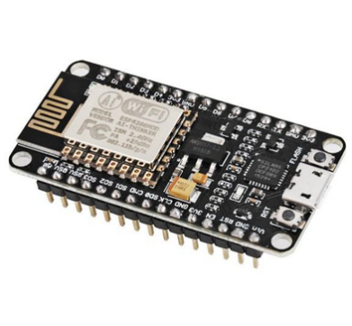

**Figure 2.1 ESP8266 Wi-Fi Module**

Source: https://probots.co.in/

**2.2 Reason Using ESP8266**

Since ESP8266 is generally been use by most industry nowadays for many projects. Therefore, there were a lot of different modules of ESP8266. The reason ESP8266 been choose in this project: -

**2.2.1 Cost**

It is so cheap that people would be willing to give it a try. Even if you break it, you won’t feel you are wasting much money.

**2.2.2 More Compatible Development Environments**

The compatibility of Arduino development is a great milestone. Afterwards, more software engineers proposed new ways to develop ESP8266, such as using eLua language in NodeMCU project, using JavaScript in Smart.js project and convert the project to Mongoose IoT Firmware, and using Python in Micro Python project.

**2.2.3 Flexible Design and Enhanced Function**

Flexible Design and Enhanced Function of ESP8266 chip and board have been enhanced as well, like chip clock rate acceleration, a new analogue digital converter (ADC) to improve the sensitivity. Connecting with soil humidity sensor is a common application.

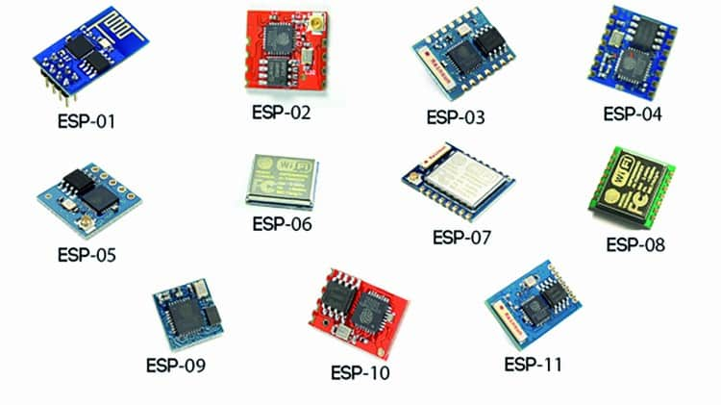

**Figure 2.2 Different Design and Modules ESP8266**

Source: http://www.open-electronics.org/the-esp-wifi-shield-the-best-value-for-money-and-low-energy-consumption/

**2.2.4 Learning Resources**

Due to the growing attention on ESP8266, textbook publisher got interest to introduce the new chip. as it became more famous, the related information was translated to English, helping the global promotion. O’reilly’s English version now is available. The related topics and books in Japanese, Arabic, Italian, etc all can be found on the market.

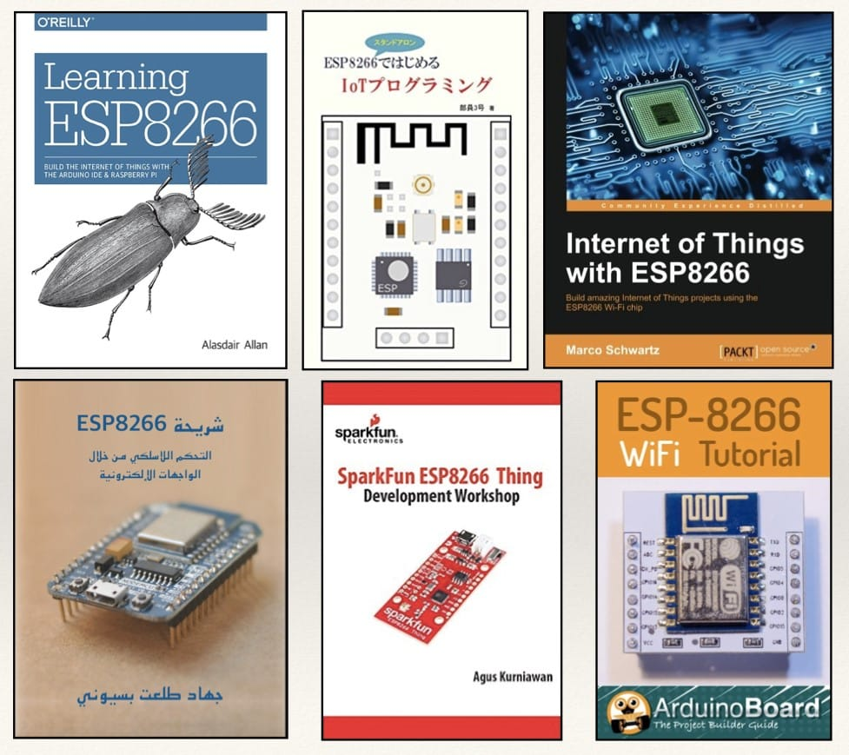

**Figure 2.3 Books about ESP8266**

Source: http://makerpro.cc/2017/01/why-esp8266-so-popular/

**2.2.5 Convenient Application Development**

Nowadays it has become quite easy to develop with ESP8266. In terms of hardware, makers only need to plug and use, and all the tough tasks used to be required in professional electronic engineering are all saved. Makers can use the simple command program and even smartphone app to set up. Various programming languages, thus, can be used to develop ESP8266, such as JavaScript, Java, Python, Objective C (common programming language on Mac and iOS), PHP, Ruby, etc. API can be applied to smartphone, webpage, and even IFTTT.

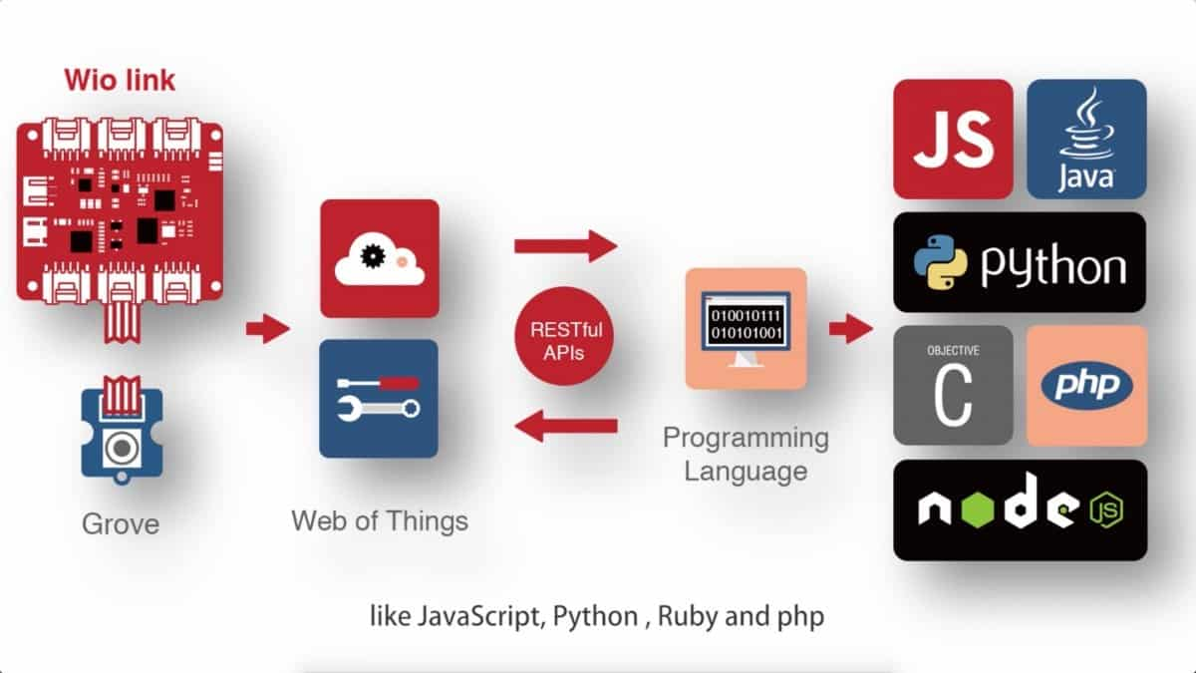

**Figure 2.4 Various Application Development**

Source: http://www.seeedstudio.com/blog/2015/12/04/wio-link-has-reached-funding-goal-in-5hrs-and-thanks-all-for-your-support/

**2.2.6 Incentive Program**

Online incentive programs also accelerated the ESP8266 software development. For example, anyone who can implement some function or application with ESP8266 will get the prize. Besides, Expressif also has an incentive program that once anyone who finds bug in the SDK and got approve will get cash USD$1000 – 2000 in cash prize.

**2.3 Different Modules of ESP8266**

As we know that there are a lot of Modules of ESP8266 and all the modules have their own characteristics. Table 1.0 shows some comparison and characteristic ESP8266 modules.

**Table 2.1 Comparison and Characteristic ESP8266 Modules**

|  |  |  |  |  |  |  |  |  |
| --- | --- | --- | --- | --- | --- | --- | --- | --- |
| **Board Id** | **Pins** | **Pitch (mm)** | **LEDs** | **Antenna** | **Antenna Socket** | **Shielded** | **Dimensions (mm)** | **Flash Size in Bytes and**  **(Mega Bits)** |
| **ESP-01** | 8 | 2.54 | Yes | PCB | No | No | 14.3 x 24.8 | 512Kb (4Mb) |
| **ESP-02** | 8 | 2.54 | No | U. FL Socket | Yes | No | 14.2 x 14.2 | 512Kb (4Mb) |
| **ESP-03** | 14 | 2.00 | No | Ceramic | No | No | 17.3 x 12.1 | 512Kb (4Mb) |
| **ESP-04** | 14 | 2.00 | No | - | No | No | 14.7 x 12.1 | 512Kb (4Mb) |
| **ESP-05** | 5 | 2.54 | No | - | Yes | No | 14.2 x 14.2 | 512Kb (4Mb) |
| **ESP-06** | 12+GND | 2.70  2.90 | No | - | No | Yes | 16.3 x 13.1 | 512Kb (4Mb) |
| **ESP-07** | 16 | 2.00 | Yes | Ceramic + U. FL Socket | Yes | Yes | 21.2 x 16.0 | 1Mb (8Mb) |
| **ESP-07S** | 16 | 2.00 | No | U. FL Socket | Yes | Yes | 17.0 x 16.0 | 4Mb (32Mb) |
| **ESP-08** | 14 | 2.00 | No | - | No | Yes | 17.0 x 16.0 | 4MB (32Mb) |
| **ESP-08 New** | 16 | 2.00 | No | - | No | Yes | 18.0 x 16.0 | 4MB (32Mb) |
| **ESP-09** | 12+GND | 1.90 | No | - | No | No | 10.0 x 10.0 | 1Mb (8Mb) |
| **ESP-10** | 5 | 2.00 | No | - | No | No | 14.2 x 10.0 | 512Kb (4Mb) |
| **ESP-11** | 8 | 1.27 | No | Ceramic | No | No | 17.3 x 12.1 | 512Kb (4Mb) |
| **ESP-12** | 16 | 2.00 | Yes | PCB | No | Yes | 24.0 x 16.0 | 4Mb (32Mb) |
| **ESP-12F** | 22 | 2.00 | Yes | PCB | No | Yes | 24.0 x 16.0 | 4Mb (32Mb) |
| **ESP-12E** | 22 | 2.00 | Yes | PCB | No | Yes | 24.0 x 16.0 | 4Mb (32Mb) |
| **ESP-12S** | 16 | 2.00 | Yes | PCB | No | Yes | 24.0 x 16.0 | 4Mb (32Mb) |
| **ESP-13** | 18 | 1.50 | No | PCB | No | Yes | 20.0 x 19.9 | 4Mb (32Mb) |
| **ESP-14** | 22 | 2.00 | Yes | PCB | No | Yes | 24.3 x 16.2 | Unknown |
| **ESP-201** | 26 | 2.54 | Yes | PCB | Yes | No | 33.5 x 25.5 | 512Kb (4Mb) |
| **WROOM-02** | 18 | 1.50 | No | PCB | No | Yes | 20.0 x 18.0 | Unknown |
| **WT8266-S1** | 18 | 1.50 | Yes | PCB | No | Yes | 15.0 x 18.6 | 4Mb (32Mb) |

**\*U. FL Socket** - (Ultra-small Surface-mount Coaxial Connector Socket)

**2.4 Arduino Microprocessor**

Arduino board designs use a variety of microprocessors and controllers. The boards are equipped with sets of digital and analogue input/output (I/O) pins that may be interfaced to various expansion boards ('shields') or breadboards (For prototyping) and other circuits. The boards feature serial communications interfaces, including Universal Serial Bus (USB) on some models, which are also used for loading programs from personal computers. The microcontrollers can be programmed using C and C++ programming languages. In addition to using traditional compiler toolchains, the Arduino project provides an integrated development environment (IDE) based on the Processing language project.

Arduino microprocessor comes in various type:

**TABLE 2.2 Comparison Between Arduino Microprocessor**

|  |  |  |  |  |  |  |  |  |
| --- | --- | --- | --- | --- | --- | --- | --- | --- |
| **Name** | **Analog (pins)** | | **Processor** | | **Voltage** | **Dimensions** | **Flash(kB)** | **Comment** |
|  | **Output** | **Input** | **Frequency** | **Processor** |  |  |  |  |
| **Arduino Uno** | 0 | 6 | 16MHz | ATmega328P | 5V | 68.6 mm x 53.4 mm | 32 | This uses the same ATmega328 as late-model Duemilanove, but whereas the Duemilanove used an FTDI chip for USB, the Uno uses an ATmega16U2 (ATmega8U2 before rev3) programmed as a serial converter. |
| **Arduino Uno Wi-Fi rev 2** | 0 | 6 | 16MHz | ATMEGA4809, NINA-W132 Wi-Fi module from u-blox, ECC608 crypto device | 5V | 68.6 mm x 53.4 mm | 48 | Contains six-axis accelerometer, gyroscope the NINA/esp32 module supports Wi-Fi and support Bluetooth as Beta feature |
| **Arduino Fio** | 0 | 8 | 16MHz | ATmega328P | 3.3 V | 66.0mm × 27.9mm | 32 | Includes XBee socket on bottom of board. |
| **Arduino Ethernet** | 0 | 6 | 16MHz | ATmega328 | 5V | 68.6mm x 53.3 mm | 32 | Based on the same WIZnet W5100 chip as the Arduino Ethernet Shield. A serial interface is provided for programming, but no USB interface. Late versions of this board support Power over Ethernet (PoE). |

**2.5 Summary**

Since there are a lot of ESP8266 versions, therefore, ESP-12E have been choose for this project. The reason for choosing ESP-12E are because it can discrete components using transistors and using standard integrated circuits such as 74HCxx parts, micro-controllers as PIC microcontrollers, ATMEL microcontrollers and ARM microcontrollers, microcontrollers with built-in loaders such as PICAXE, Arduino (using ATMEL 8-bit microcontrollers), Arduino compatible systems not using ATMEL microcontrollers such as Chipkit (PIC32), Arduino Due(ARM) and ESP8266-Arduino. Hence, the designer can do a better project quality with ESP12-E.

**CHAPTER 3**

**Methodology**

**3.1 Introduction**

In this chapter, rules and regulation on Laboratory (LAB) also the initial process, methods and procedures to design the ESP-12E PCB board will discussed. The learning process in order to know better the ESP-12E PCB board weaknesses will be identified to improve. The essential of Soldering and Software Support also component test required in this project.

**3.2 Safety and Precaution or Equipment’s on LAB**

The safety manual of the lab should be read clearly and applied it on the lab because inside the PCB lab got some corrosive and poisonous substances which we need to use. Wear appropriate protective cloth, goggles, apron, mask,shoes and gloves because mechanical and heating element or chemical substance are also used.

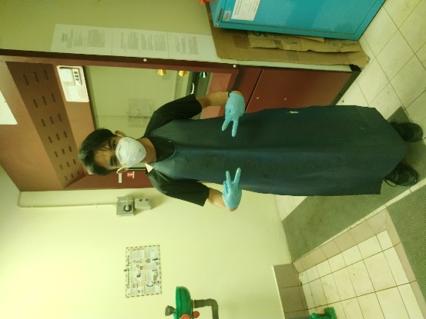

**Figure 3.0 Equipment’s that Should to be Wear on LAB**

There are also some extra rules and precaution that need to be aware of such as:

1. Warning sing and techniques handling equipment or any chemicals.

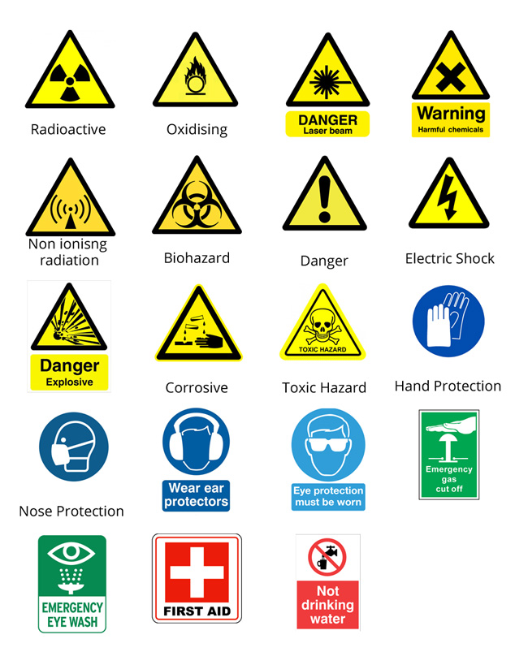

**Figure 3.1 Safety and Warning Signs**

Source: https://qknowbooks.gitbooks.io/jhs_1_science-hazards/safety_and_warning_signs_found_in_the_laboratory.html

1. Cleaning off the LAB of its equipment or substance after use.
2. Beware of safety and precaution on the LAB.

**3.2.1 Eye Washer**

Eye washer is a common thing to have in LAB. If your eyes are suddenly affected by any substance in the LAB, the eye washer is come to help.

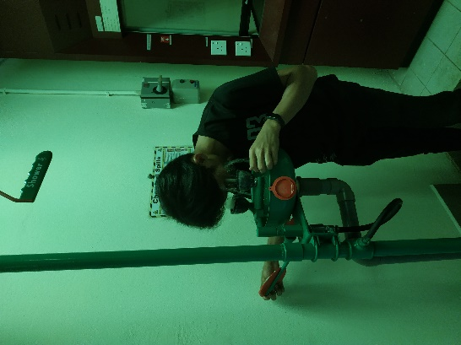

**Figure 3.2 Using the Eye Washer Equipment**

**3.3 Simulation**

**3.3.1 Installing the Proteus Demo**

Proteus is an application where virtual modelling and circuit simulation can be done in this software. It combines the mixed mode of SPICE circuit simulation, animated component and microprocessor models to facilitate co-simulation of complete microcontroller-based designs. Proteus also can simulate the interaction between the software and the digital electronics connected to it. The proteus demo only allow us to write our own software programs to run on the existing sample design suite for evaluation purpose and it does not have time limits.

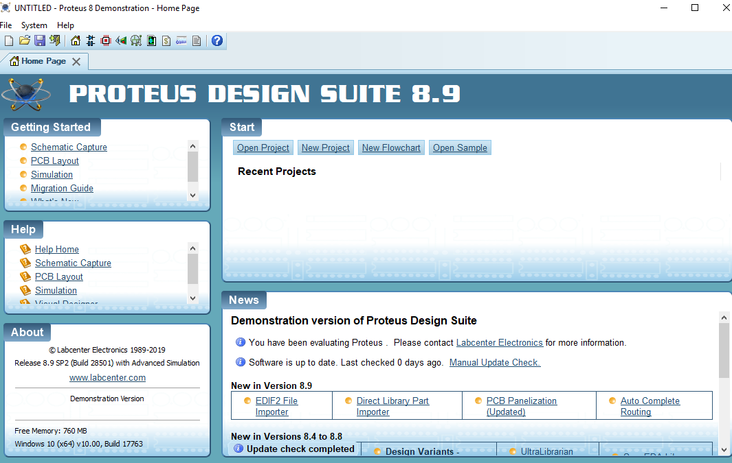

**Figure 3.3 Proteus Demo**

**3.3.2 Run the Simulation in Proteus Demo**

The simulation can be run by clicking the menu Debug or Run simulation. Here is a step-by-step on how to run the simulation:

In the Start window:

1. Open sample, search for ESP8266 in the keywords.
2. Select the Blink an LED.
3. Run the simulation by clicking the menu Debug\Run Simulation.
4. You can see the control from the Debug menu and selecting Web

Browser to open another Web Browser window. Click the button and see the result in the Schematic Diagram. It is also the same steps to simulate the ESP8266. Stimulation of Blink an LED also ESP8266 by using Proteus 8 demo are as following diagram:

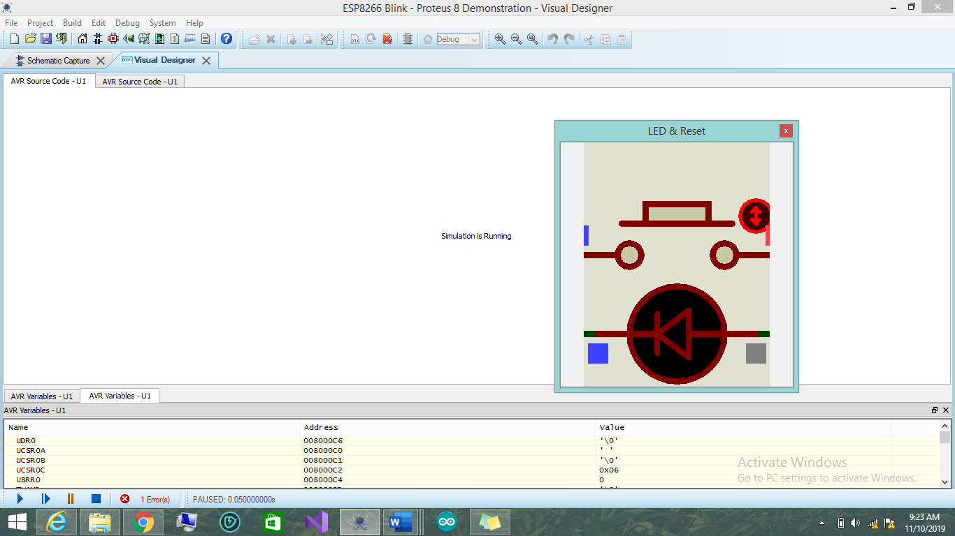

**Figure 3.4 The Result by Running the LED Blink**

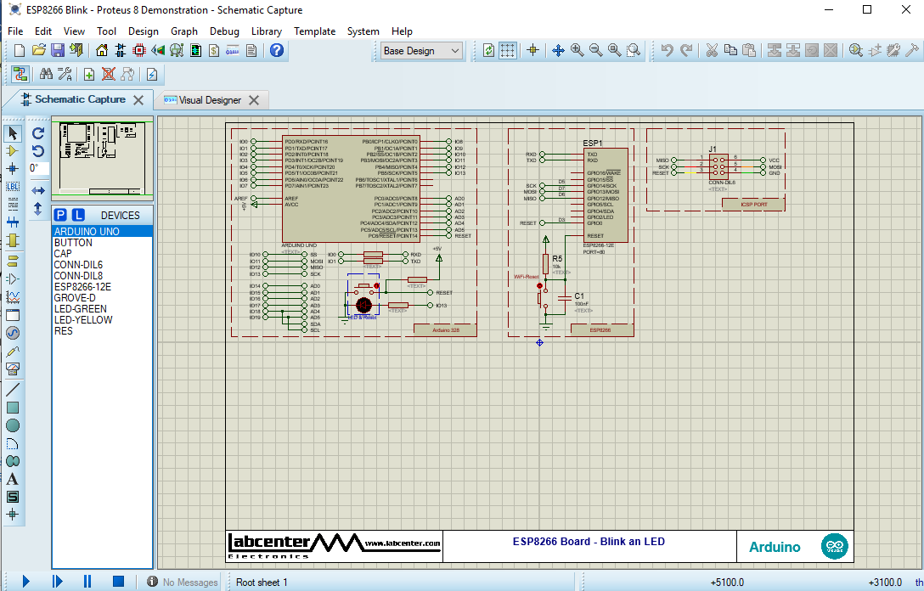

**Figure 3.5 Simulation of ESP8266**

**3.4 Installing the Additional Component**

Firstly, we need to install the SamacSys library loader. The SamacSys is uses to converts the Symbol & PCB Footprint into your chosen ECAD format, then try to loads them into your chosen library and attaches them to the cursor in your created design.

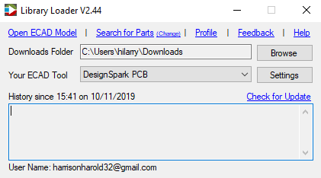

**Figure 3.6 SamacSys Library Loader**

Steps to import Symbols & footprints into Proteus:

1. Start either the Schematic or PCB layout module.
2. Invoke the 'Import Parts' command from the Library menu Next
3. Click 'Select File'.
4. Change the file type filter to the 'SnapEDA Downloads ‘option
5. Browse to the folder containing the download (. snapeda file).
6. Double click the downloaded file.
7. Choose the desired footprint (if the download contains several footprint options).
8. Click 'Import Part'.
9. Work through the Make Package and Make Device wizards as you would for a manually created part.
10. Repeat from step 3 if multiple parts have been downloaded.

**3.5 Soldering Pins ESP-12E**

Starting at soldering at thin layer of solder to the pins which called tinning. It will make it easy for the pins to solder to the board and reduce any potential damage due to overheating. Tinning improves the ease at which pins can be soldered to other tinned connectors or motherboard soldering pads. Soldering pads must be tinned also.

**3.5.1 Tinning a Pin with or Without Flux**

By doing the experiment, tinning the pin with flux is faster than without flux. The reason is with flux it is melt and tinning the pin at the same time while without flux it is otherwise.

**3.5.2 To Clean and re Tin the Soldering Iron**

Look after the tip of your soldering iron. Clean it often and coat the tip with solder. If the solder does not stick, clean the tip with paper or sponge. If the tip is dirty just tinning the tip with solder. It will give back the shiny grey like a new tip. Do not sandpaper the tip if dirty because it will destroy the tip quickly.

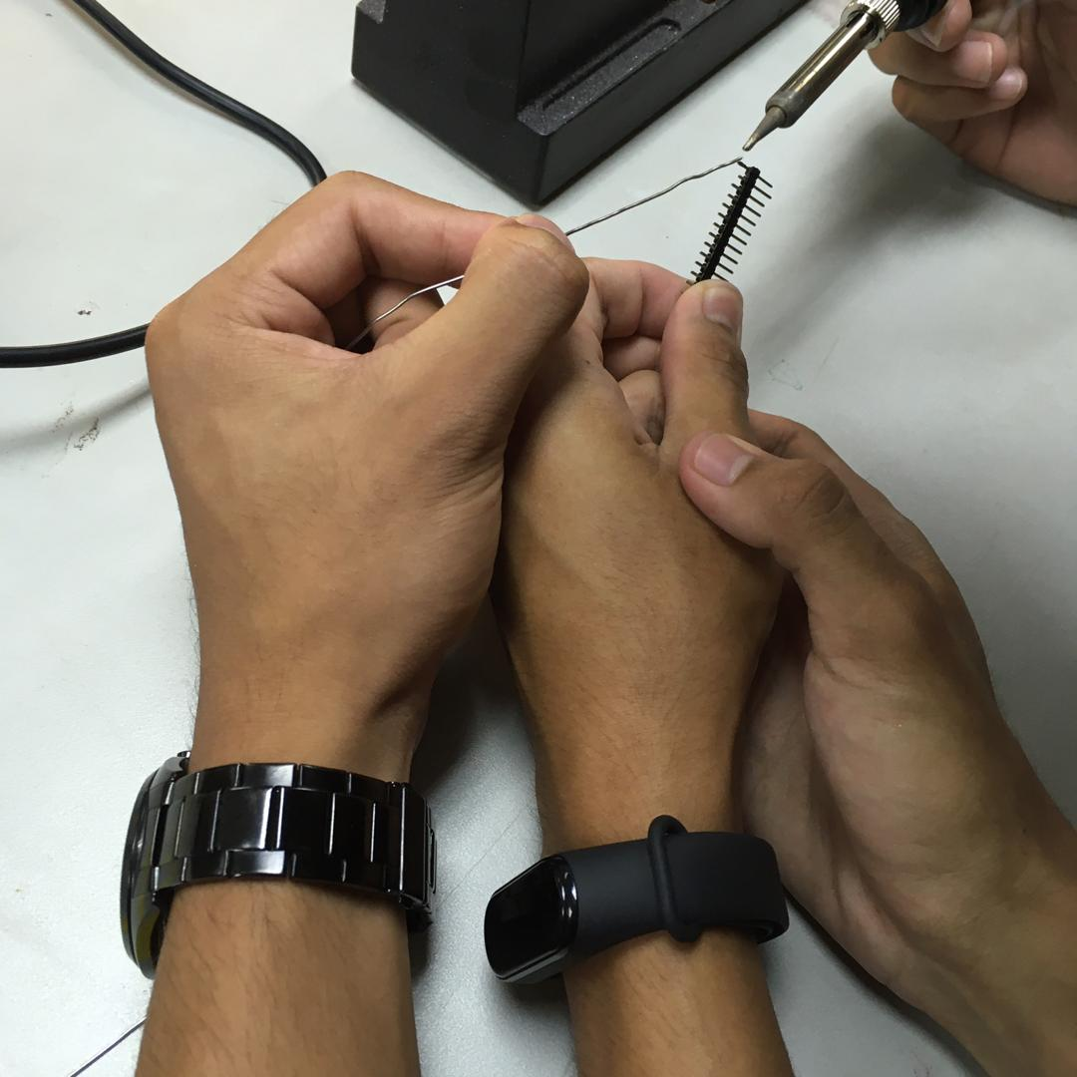

**Figure 3.7 Tinning Pin using Soldering Iron and Solder**

**3.6 DesignSpark**

Despite the advantages of Proteus, we still do not have the license for Proteus Arez, the PCB design software. We shall use DesignSpark instead since it has the same option like Proteus and freeware. Figure 3.1 shows the schematic design of ESP-12S module similarly to ESP-12E.

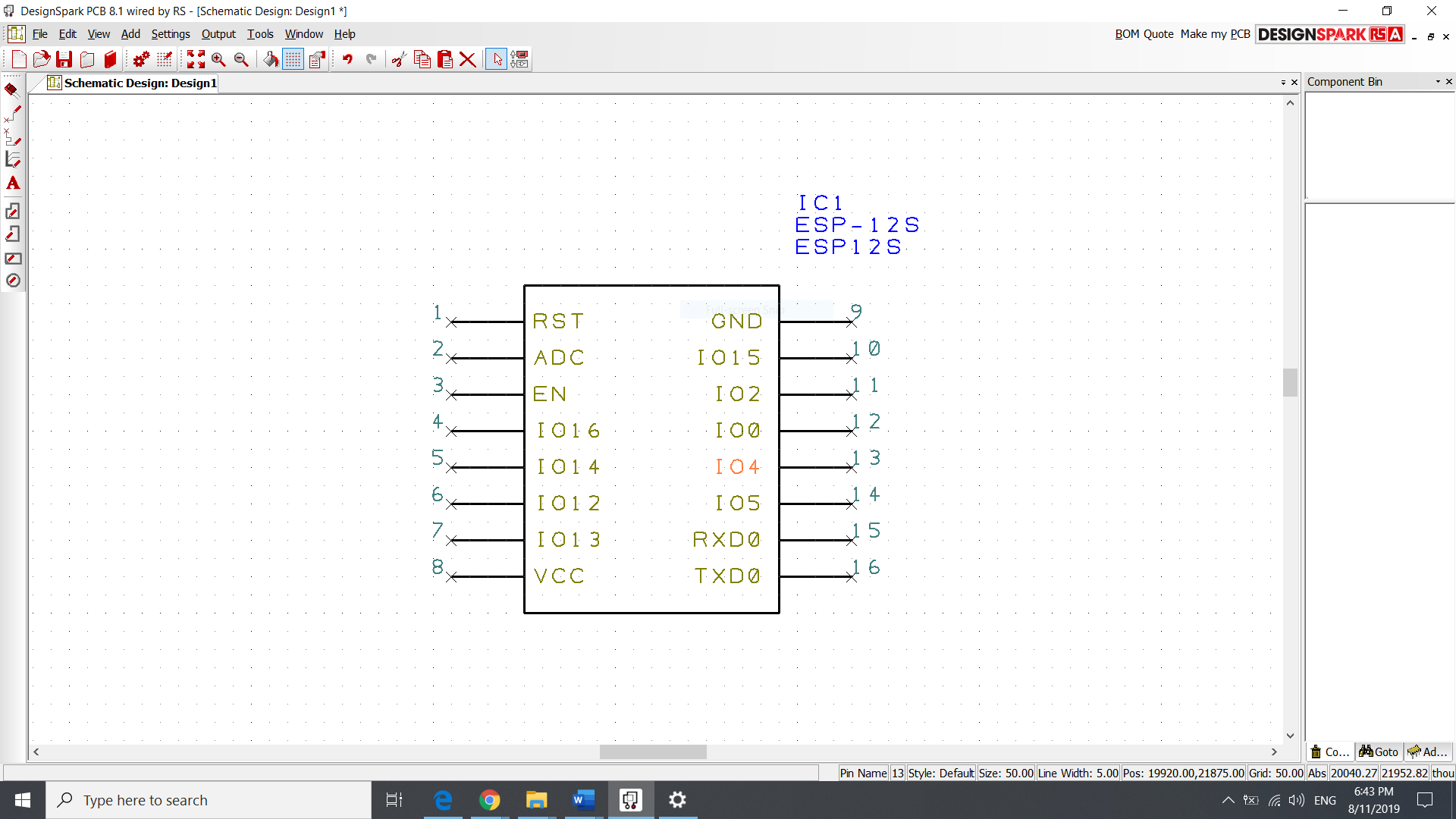

**Figure 3.8 Schematic Design ESP8266-12S**

On DesignSpark, the learning process of DesignSpark PCB Basic Course will be Familiarisation, Schematics, Translate to PCB, Exporting, Libraries, Creating Component and Adding Copper Pour to Design Spark PCB. ESP8266-12S is been used because the ESP8266-12E does not exist on Library Loader of DesignSpark. But it can be adjusted to ESP-12E by the following options:

**3.6.1 Familiarisation**

This step is just a beginning or an introduction of key point selection on DesignSpark. From this we can also learn how to create a new project and import of our own design board.

**3.6.2 Schematics**

On Schematics, the learning process of adding shape or component to your PCB board. There are many options of shapes or lines available to design your own PCB board as much as you wanted.

**3.6.3 Translate to PCB**

Translate to PCB is pretty simple since we just need the Schematics Design of our board and proceed to “Tools” and click the option “Translate To PCB”. After translate it we can modified the random component that was already given automatically to our own placement of the components anywhere around the PCB board.

**3.6.4 Exporting**

Just go through to “Output” option and click “DesignSpark Mechanical (IDF)” and click Ok. It will save your PCB board safely.

**3.6.5 Libraries**

In case drawing your own schematics, design is very hard, we can just import the Schematics Design from the Library Loader easily without wasting time draw it. Unfortunately, some PCB Schematics Design does not exist in the Library Loader such as Figure 1.0 case. Hence, to cut some time again, we just need to download the similar PCB board from the Library Loader and modified it a little bit to become the PCB board that we wanted.

**3.6.6 Creating Component**

Similarly, to 3.3.2 Schematics, we can modify or design our own PCB Board with the option given in DesignSpark.

**3.6.7 Adding Copper Pour to Design Spark**

Make sure to do the copper pour to surround our signals with copper instead of them

being etched away. It is good to copper pour for both sides with ground but make sure the

spaces for the other lines are large enough.

**3.7 Ohmmeter and Voltmeter**

Use the given multimeters and ESP-12E module as your base to take the reading on Ohmmeter and Voltmeter.

**3.7.1 Ohmmeter Reading**

Each student must test one short circuit, different from each other, between similar signals such as GND, VCC, or signal pins, and one open circuit between tracks with different names. Different combinations for each student in the same group of 5.

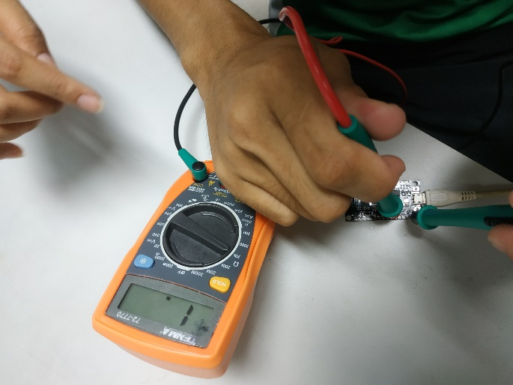

**Figure 3.9 Taking Ohmmeter Reading**

**3.7.2 Voltmeter Reading**

Power your ESP8266 module using micro USB connectors. Measure the voltages of the power pins. Each student must test different power pin and ground combinations, in the same group of 5.

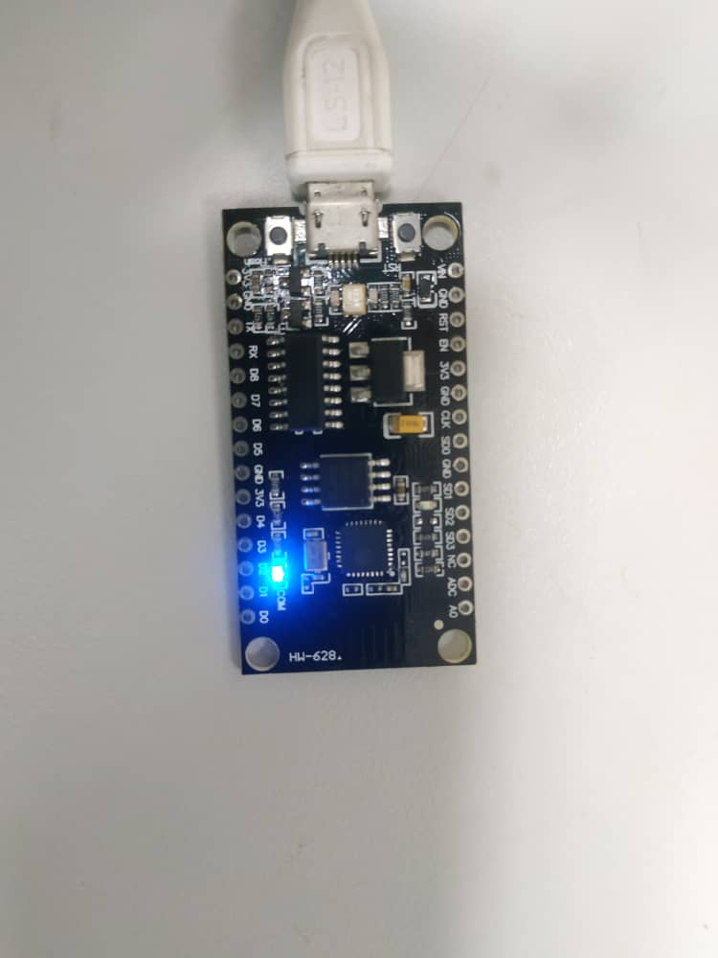

**Figure 3.10 USB Connected to PCB Connector**

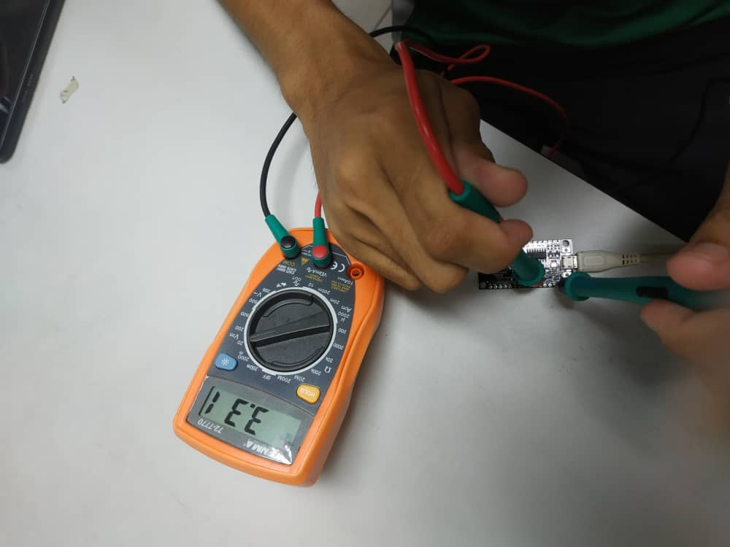

**Figure 3.11 Taking Voltmeter Reading**

**3.7.3 Precaution Steps**

Check the quality of tracks and detect short circuits by using multimeters.

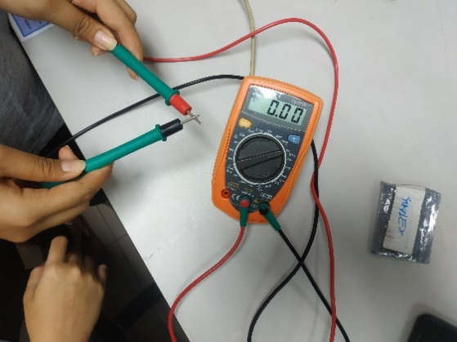

**Figure 3.12 Checking Short Circuit**

1. Use ohmmeter to measure resistances.
2. Use voltmeter to measure voltages and polarities of batteries.
3. Connect the ESP8266 using socket pins.
4. Once satisfied with the position of components, finalising your PCB board.

**3.8 Design Own PCB Board Using DesignSpark**

By using the options on 3.6 DesignSpark, we can run the simulation of our PCB Board. Here are the descriptions of making the PCB Board using DesignSpark:

The finale result of schematic design of own project are as on Figure 3.13 after adding some components such as 3 Way Pin Header and ESP12E. Every component has been routed to their own category such as 3v3, GND and D7 to make the board works.

Figure 3.14 happened after we select on the area; we want to add copper which are the red area.

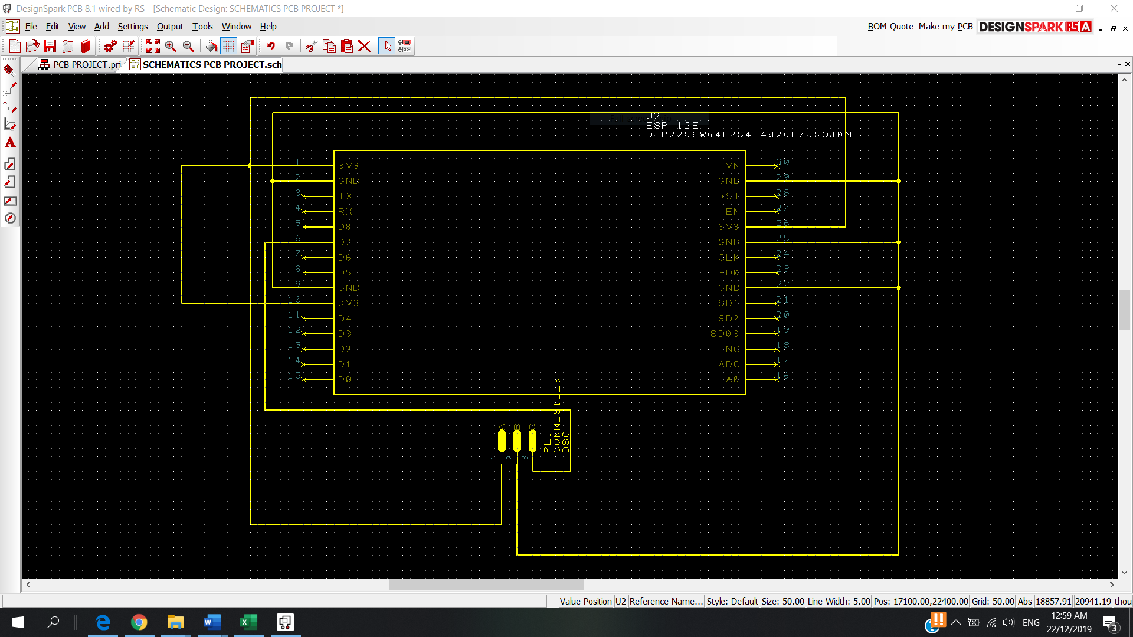

**Figure 3.13 Schematics Design own PCB Project**

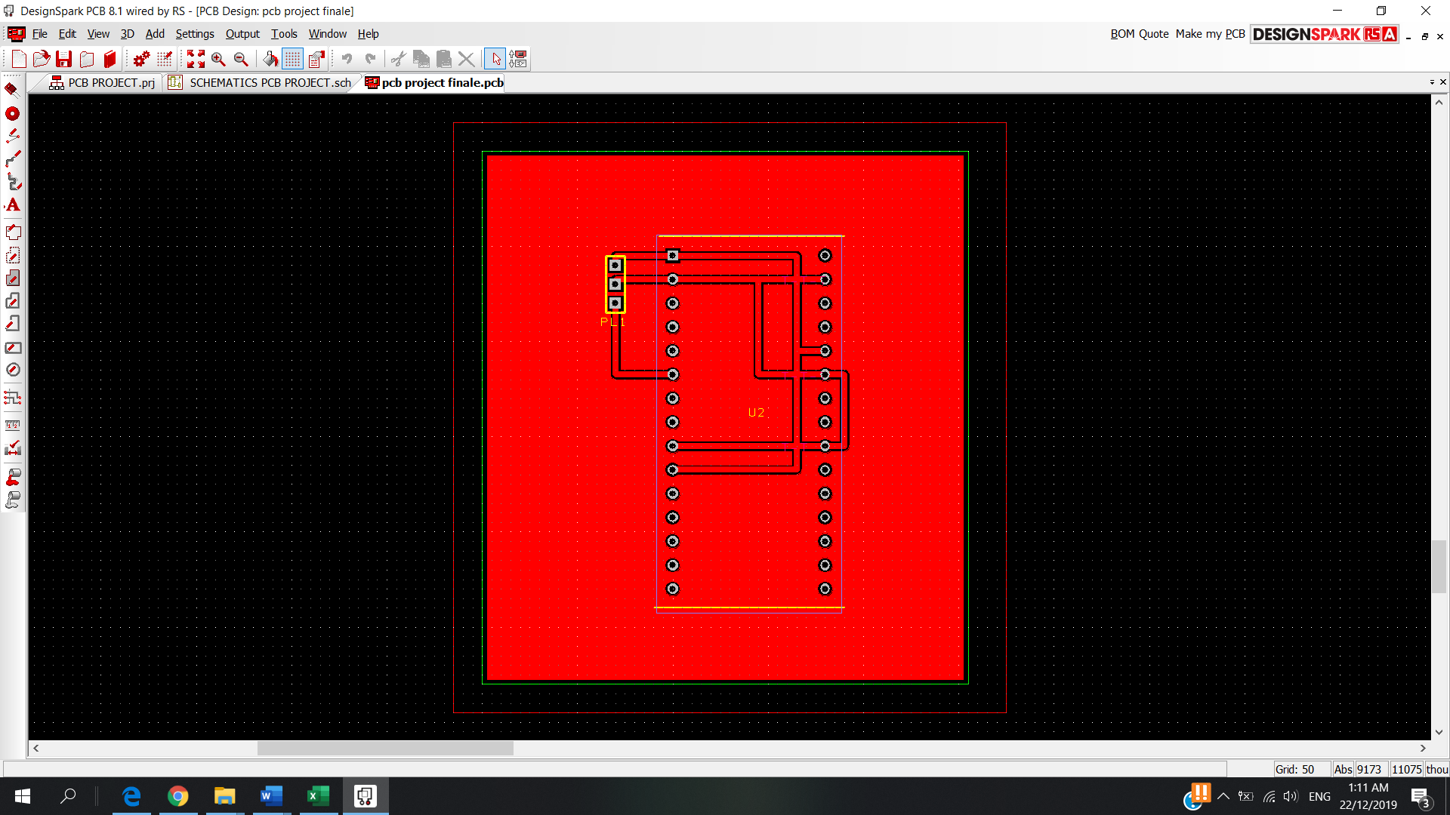

**Figure 3.14 The Project Design after Connected the Wires, Components, Adding Cooper**

**3.8.1 PCB Design**

PCBWay is the preferred fabricator from the target design rule for commercial sources.

**3.8.1.1 Solder Mask**

After adding the cooper at the planes board we should solder mask it in order to avoid short circuit on the board also Solder mask or solder stop mask or solder resist is a thin lacquer-like layer of polymer that is usually applied to the copper traces of a printed circuit board (PCB) for protection against oxidation and to prevent solder bridges from forming between closely spaced solder pads.

Here are the steps to solder mask and silkscreen on Design Spark:

Launch the Design technology Shift + T and click 'add' and fill out the details as shown.

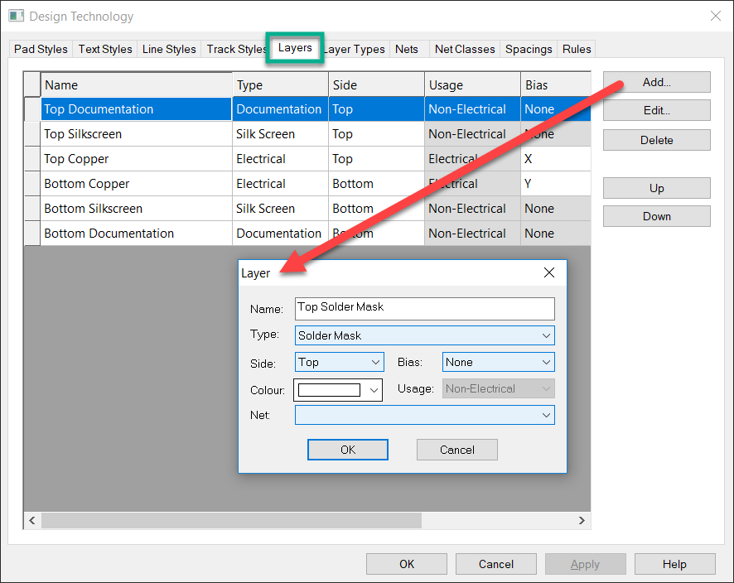**Figure 3.15 Step Layers Option**

Move layers in the stack for the correct order they physically appear in.

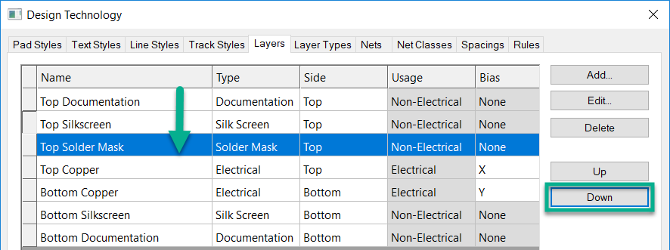

**Figure 3.16 Step Down Option**

Using the interaction bar, you will see your new layer as shown.

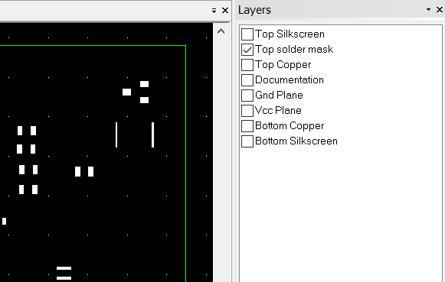

**Figure 3.17 Step Choose Layer Option**

Repeating the above selecting the appropriate details you can created a bottom solder mask.

**3.8.1.2 Adding Text On Top Silkscreen Of Board**

We can add text on the board at the top off the silkscreen of the board.

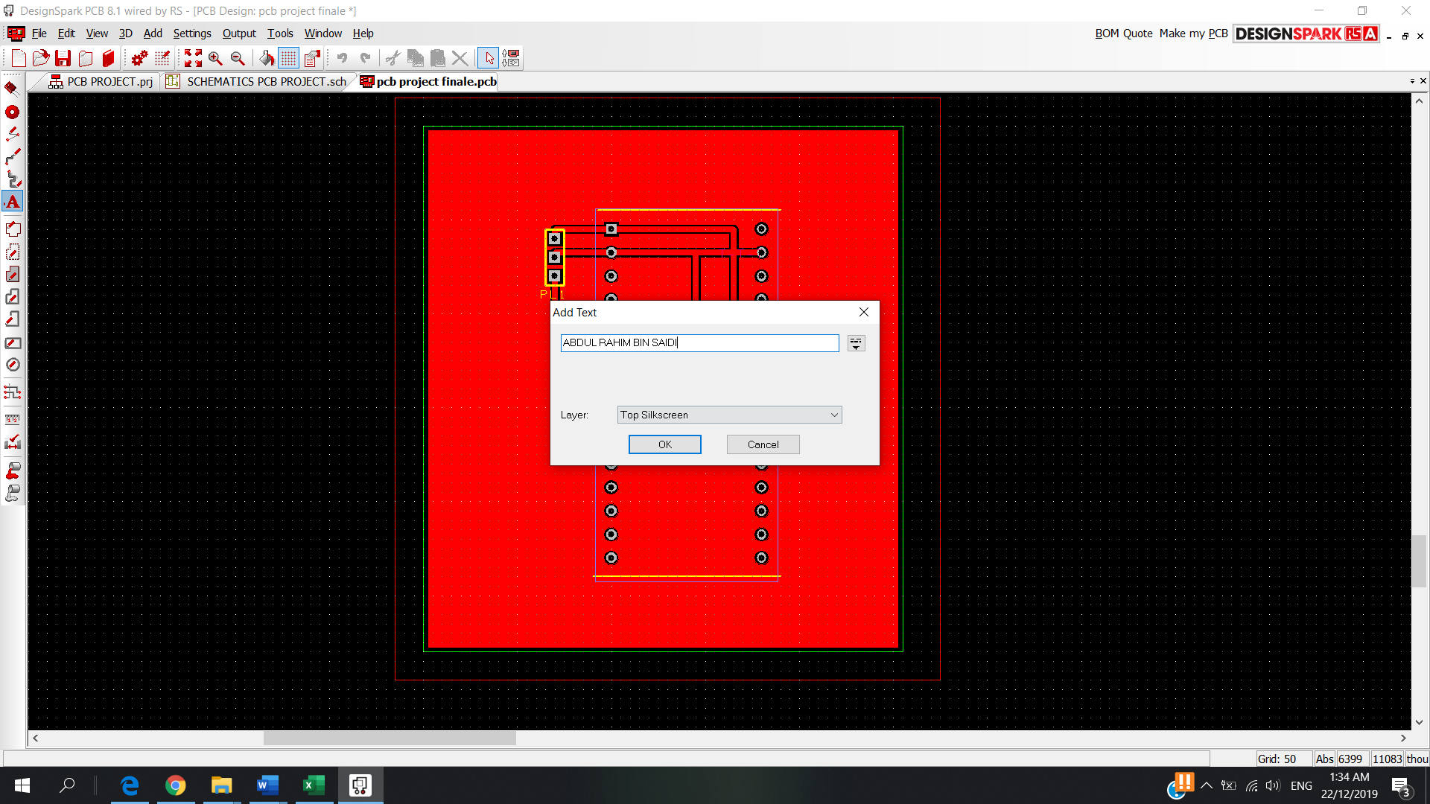

**Figure 3.18 Adding Text Silkscreen**

**3.8.1.3 Difference Between Solder Mask and Paste Mask**

Here are some differences between solder mask and paste mask:

1. The openings on solder mask layer have no solder mask ink, but the openings on paste mask layer have paste.
2. The solder mask layer is one part on the circuit board, but the paste mask layer is not. Paste mask layer is just for the stencil.
3. Solder mask is used for applying solder mask ink, but paste mask is used for applying paste
4. Solder mask is applied when making PCB board, but paste mask is used when assembling.
5. Solder mask has many available colours, but paste mask is usually grey.

**3.9 Process Circuits of Printed Wiring Boards**

This is the final steps that need to be taken in order to achieve the objective of this project. There are few steps that need to be considered because this step needs to be repeated from the beginning if it fails one of the steps.

**3.9.1 Mask**

Before Mask, we need to cut the board that agree size with your PCB Design,

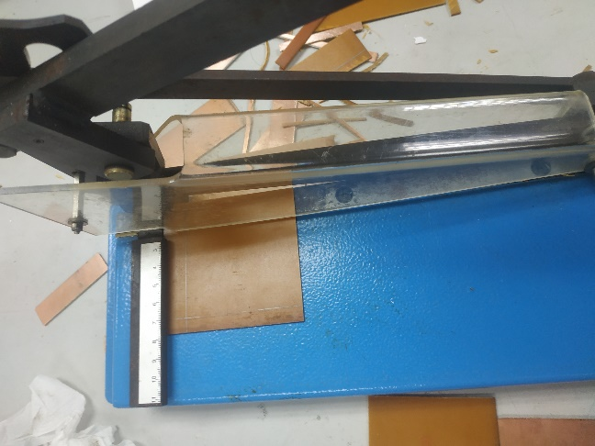

**Figure 3.19 Cutting the PCB Board**

Then clean it with sand paper to make sure the Design can be pasted easily and completely on the PCB board.

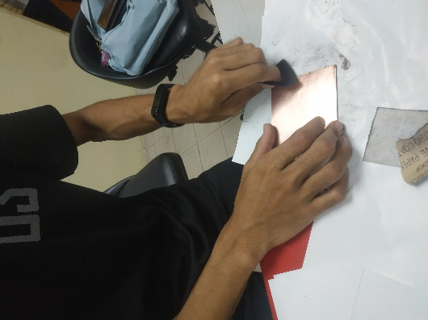

**Figure 3.20 Clean the PCB Board with Sand Paper**

Here the Mask step is the step where you paste the pdf hard copy of the final PCB design into the PCB board by using the ironing clothe for 10-20 minutes to make sure it completely pastes on the board. Before that wrap the Printed PCB Design Glossy Paper with the PCB board that need to paste on. Make sure to cover the table with tissue to absorb heat.

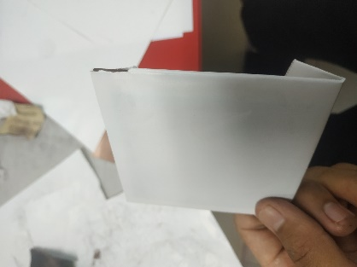

**Figure 3.21 The PCB Board been wrapped with the Printed PCB Design on Glossy Paper**

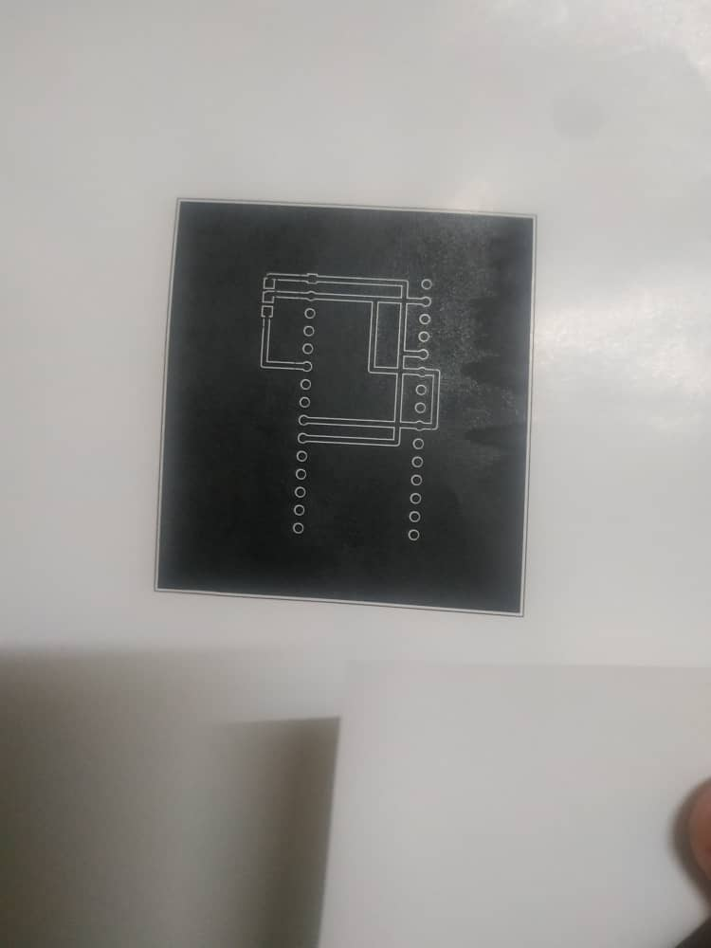

**Figure 3.22 PDF PCB Design Printed on Glossy Paper**

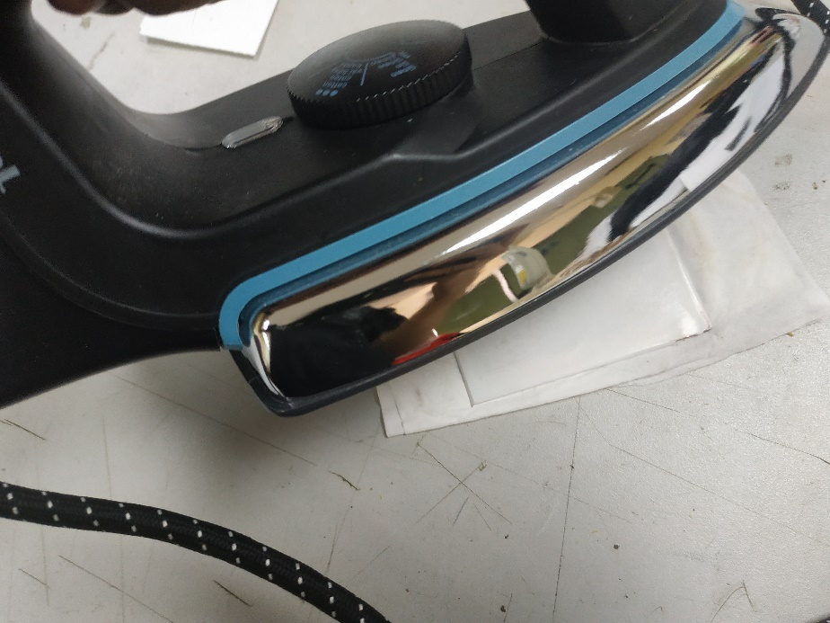

**Figure 3.23 The Printed PCB Design been Iron to the Board**

After Ironed, fully drown it to the water for 10 minutes,

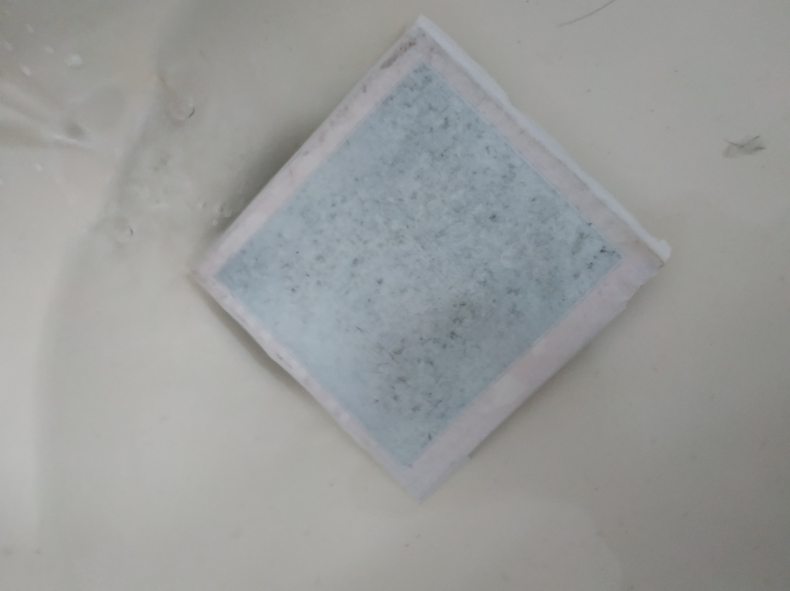

**Figure 3.24 The Wrapped Ironed PCB Board Fully Soaked to Water**

After Soaked it, remove the glossy paper from the board carefully to give the best design on the board. Make sure the line is completely clear from any dirt before the process of Etching.

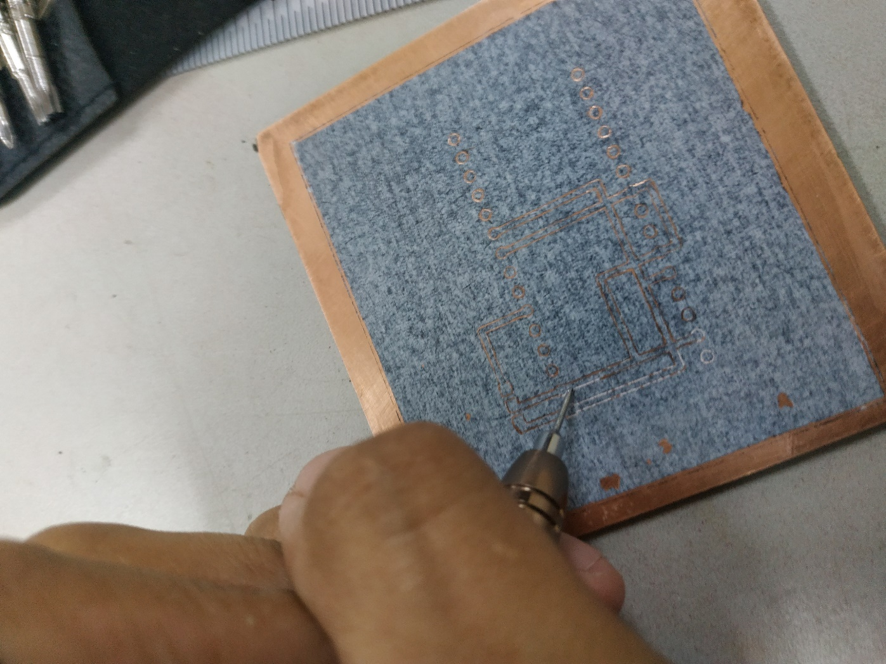

**Figure 3.25 The Design Line on The PCB Board Cleared from Dirt**

**3.9.2 Etching**

Etching is a "subtractive" method used for the production of printed circuit boards: acid is used to remove unwanted copper from a prefabricated laminate. This is done by applying a temporary mask that protects parts of the laminate from the acid and leaves the desired copper layer untouched. The acid that been used is Ferric Chloride ( FeCl3 ).

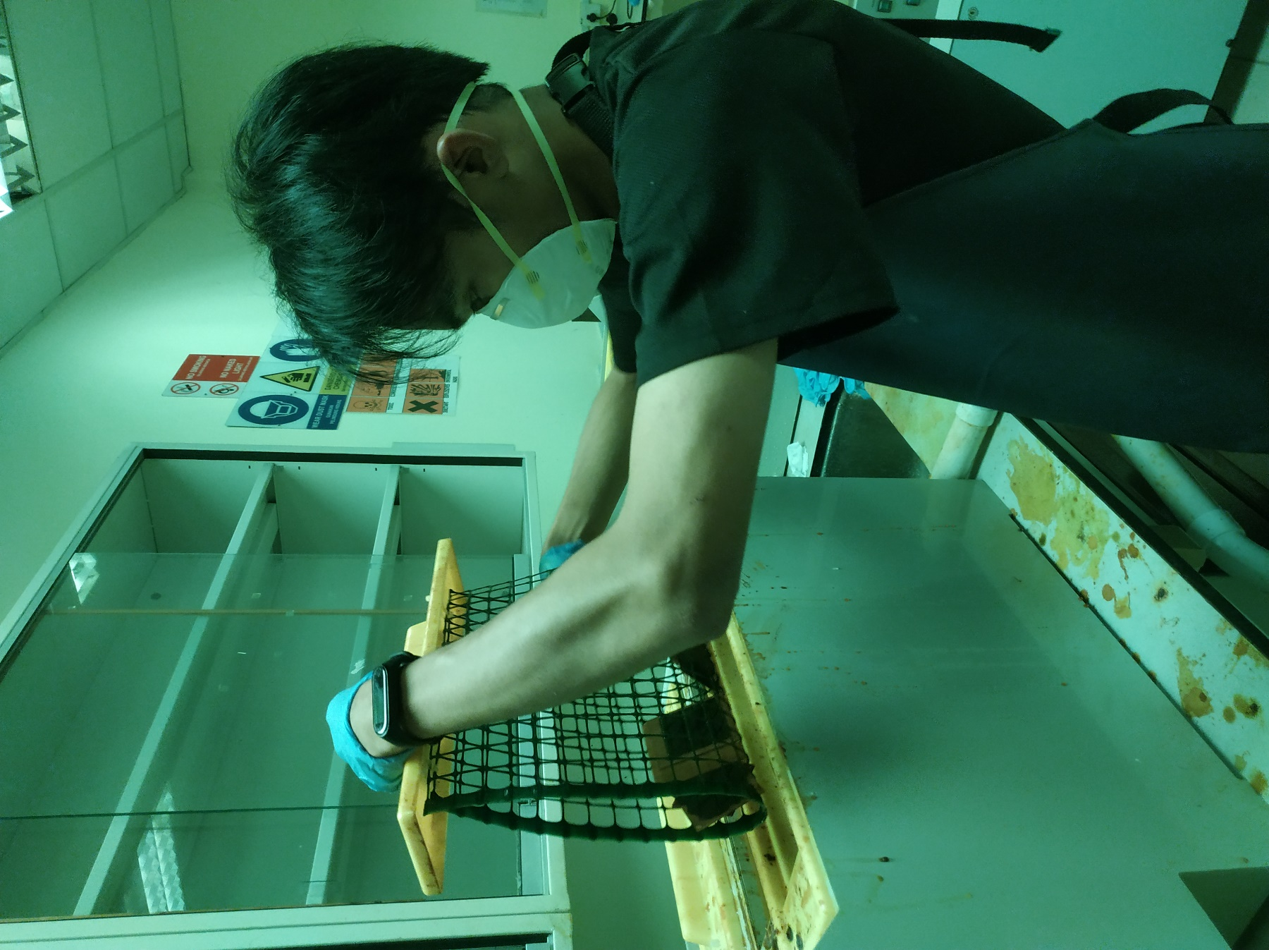

**Figure 3.26 The PCB board soaked into the Acid for 10 Minutes**

**3.9.3 Drilling**

Drilling is the manufacturing process where a round hole is created within a work piece or enlarged by rotating an end cutting tool, a drill. Reaming is a similar process where a hole feature is enlarged to a very specific or accurate size by introducing a rotating end and side cutting tool called a reamer. The drill size that been used for the PCB board is 1.20mm.

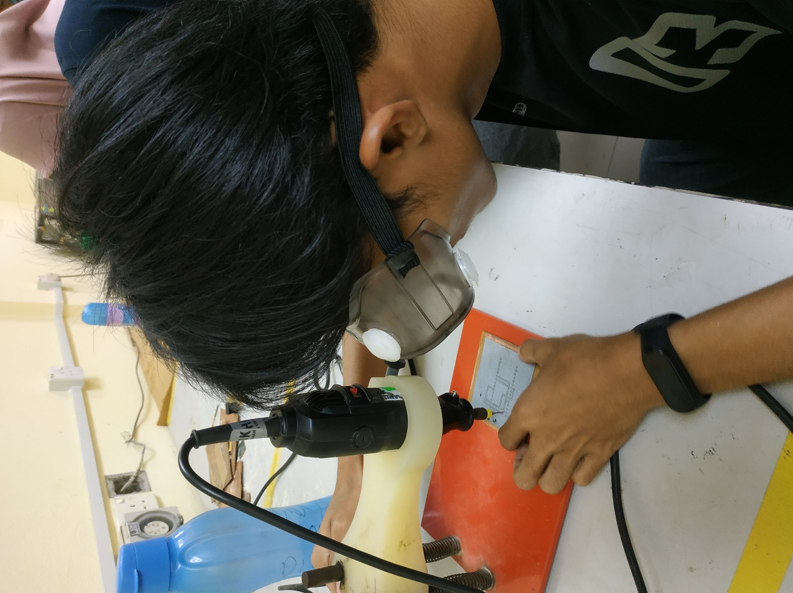

**Figure 3.27 Drilling the PCB Board**

After drilling, make sure to use the sand paper to clear the PCB Board and left the design of your PCB Board on board.

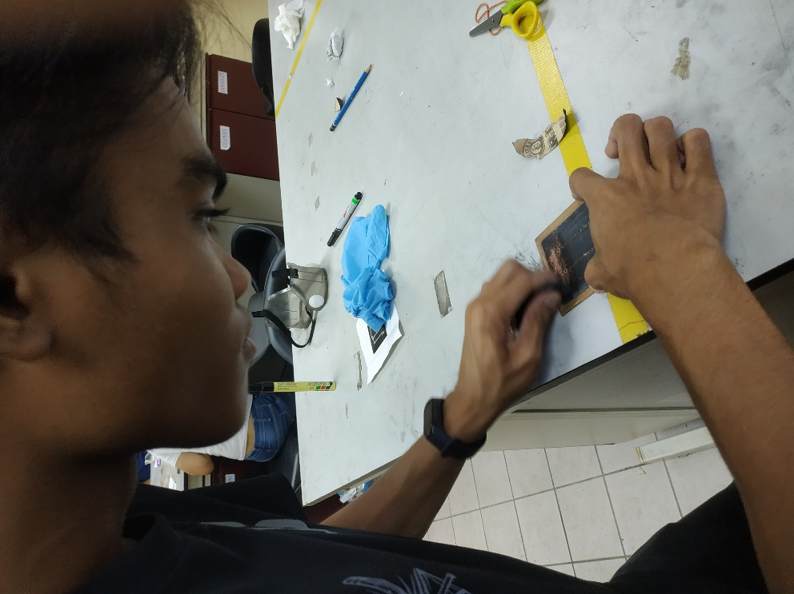

**Figure 3.28 Clear the PCB Board using Sand Paper after Drilling**

**3.9.4 Precaution Steps**

1. Make sure to Mask the PCB Board completely within time not more not less.
2. Make sure to use maker pen if there some hole after mask to protect areas from being etched by acid.
3. Make sure to fully soaked into the acid when etching the PCB board.
4. Make sure to use glove when dealing with the acid.
5. Make sure to clean the acid from the board after etching with water completely.
6. Make sure to drill the PCB board carefully and wear google when drilling.

**CHAPTER 4**

**OBSERVATION AND RESULT**

**4.1 Introduction**

This chapter will cover half of the project observation and result that already done. It will include the tinning, multimeters and DesignSpark parts.

**4.2 Tinning Pin**

The tinning part already been explained on 3.2 Soldering Pin ESP-12E. Figure 4.0 shows the pins that already been tinned.

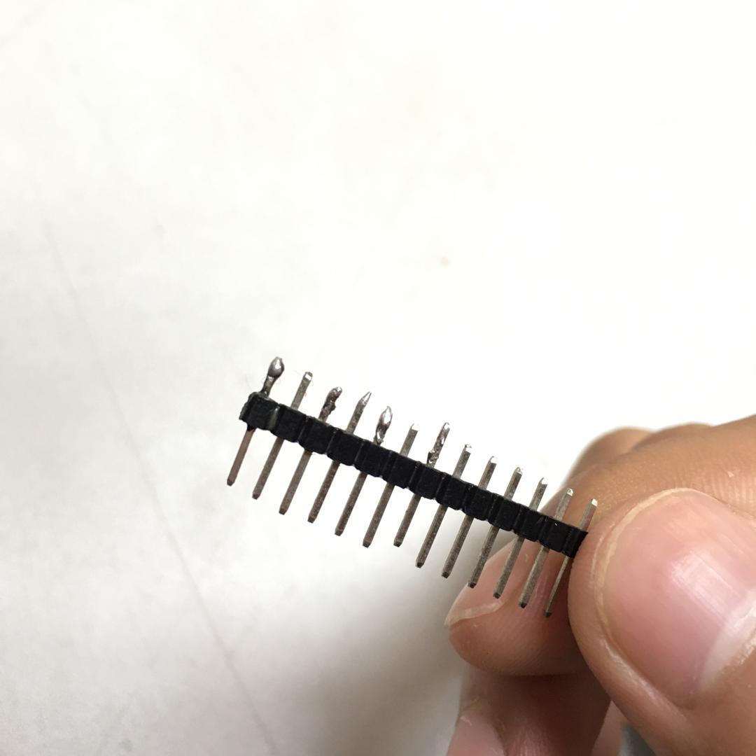

**Figure 4.0 Tinned Pins**

**4.2.1 Observation**

Some part of the pin is not tinning properly make some of the pin looks bigger than the actual size or the solder is not fully melted makes some the pins looks bulky or messy.

**4.2.2 Design**

The proper way of tinning will make the pin look literally the same and finer to look. The pin need to tinning process again until the pin satisfied the project.

**4.2.3 Characteristic Design**

The pin should be fully and properly tinning which makes the look of the pin smooth without any defect so improves conductivity and makes soldering easier, as well as quicker, which is a good thing.

**4.3 Multimeters**

The multimeters is an electrical measurement that can read Ohmmeter and Voltmeter at the same device. Digital multimeters can be very helpful pieces of test equipment and when in the right hands can solve many electrical issues. A good multimeters that is equipped with a well-designed wiring diagram, and handled by a trained professional can get to the root of just about any electrical problem. The two types of digital multimeters are the digital and the analogue and the main difference is their display reading. An analogue digital multimeters will use a needle to show results, while a digital multimeters will use an LCD or LED screen. In today’s markets there is a very high demand for accuracy which makes a digital multimeters much more practical, although many people still use analogue multimeters.

**4.3.1 Results**

Table 4.0 Ohmmeter Reading and Table 4.1 Voltmeter Reading is the reading result of Multimeters experiment from 3.4 Ohmmeter and Voltmeter.

**Table 4.0 Ohmmeter Reading**

|  |  |
| --- | --- |
| **Student** | **Resistor (Ω)** |
| **Student 1** | 1.00 |
| **Student 2** | 0.11 |
| **Student 3** | 1.00 |
| **Student 4** | 0.19 |
| **Student 5** | 1.00 |

**Table 4.1 Voltmeter Reading**

|  |  |
| --- | --- |
| **Student** | **Voltage (V)** |
| **Student 1** | 3.31 |
| **Student 2** | 0.06 |
| **Student 3** | 3.31 |
| **Student 4** | 0.02 |
| **Student 5** | 3.31 |

**4.3.2 Analysis**

Since every student take a different power pin and ground on the PCB board, there were some have the same value and different value depends on the locations choose on the PCB board.

**4.3.3 Error**

There must be some error during the experiment since 3 out of 5 students have the same value of reading. This conclude they may use the same spot power pin and ground combination at the PCB board.

**4.4 Re-Design ESP-12S to ESP-12E**

Figure 4.1 is the after re-design the ESP-12S to ESP-12E by using the step on 3.3 DesignSpark.

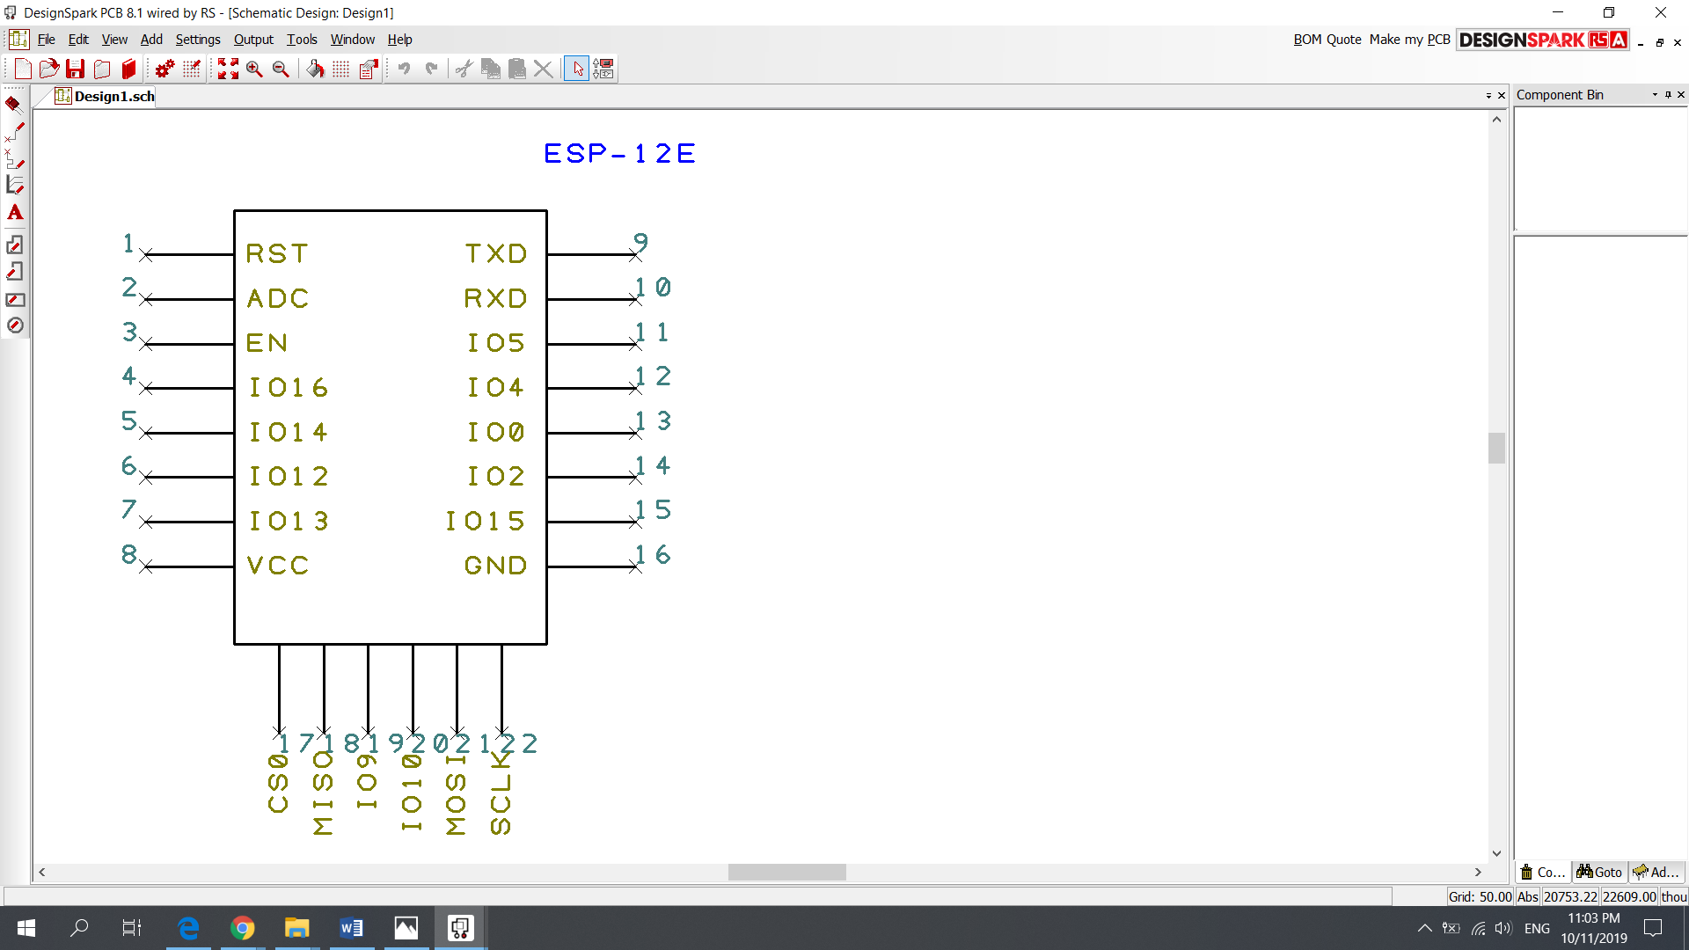

**Figure 4.1 Schematic Design ESP-12E**

**4.5 PCB Final Project Result**

After dealing with all the steps on 3.9 Process Circuits of Printed Wiring Boards, the PCB Board project successfully finished.

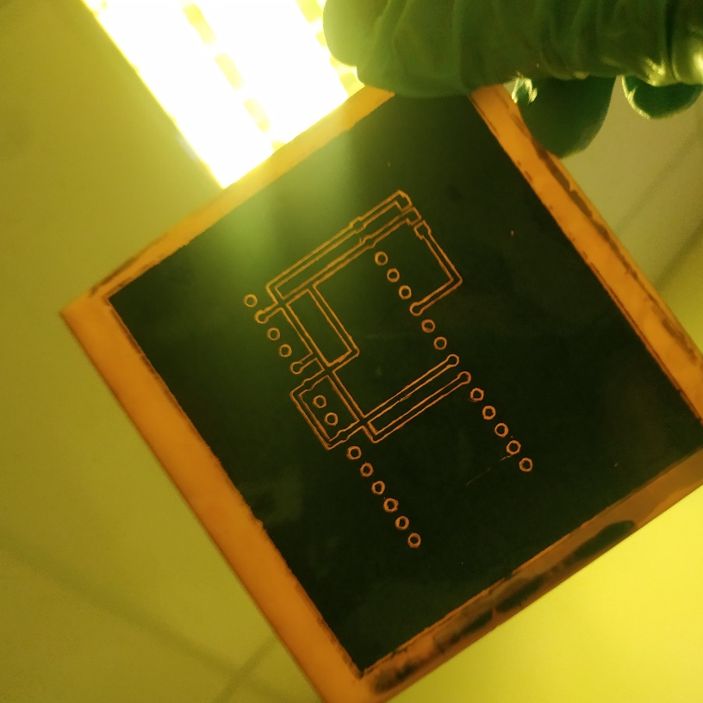

**Figure 4.2 After Etching**

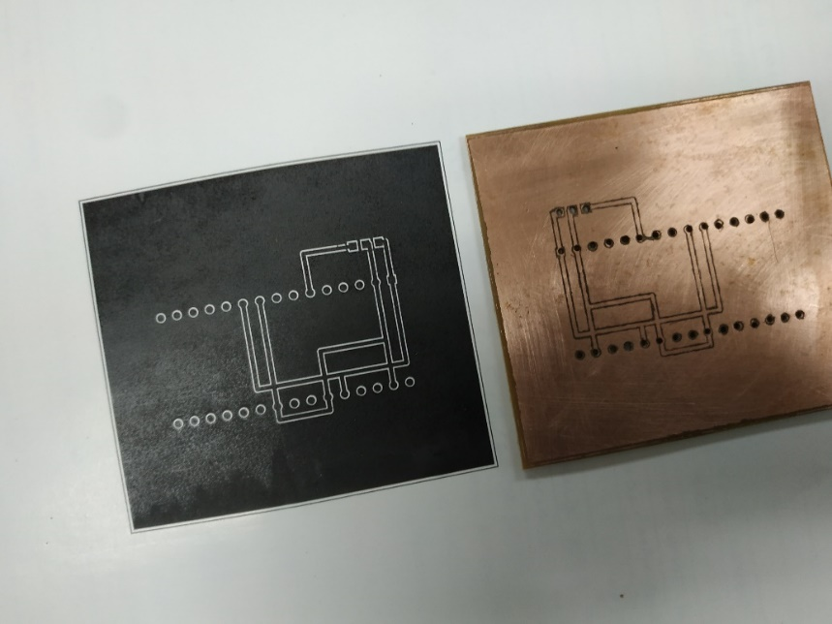

**Figure 4.3 The PCB Design on Glossy Paper (Left), The Final Result Project PCB Board (Right)**

**CHAPTER 5**

**ANALYSIS OF RESULT AND GENERAL DISCUSSION**

**5.1 Introduction**

Since the PCB design project are fully done, this chapter can conclude all the result outcome experimentally. The general discussion can be discussed since we can see the project purpose and future since the project proposal already done.

**5.2 Analysis of The Result**

Since a lot steps been taken during this Project that makes a lot of problem occur during doing this project.

**5.2.1 Error during Process of Circuit on Printed Wired Board**

1. Certain people have a problem occurred when making this project and error on his PCB project. Some the errors are:
2. The mask failed since some of the important component design is not fully pasted on the board.
3. The dirt on the PCB board makes the etching of the board unsuccessfully undone that make the PCB board looks messy then it should be.
4. When drilling, the drill goes to somewhere that should not be on the PCB board.
5. The sand paper removes the design of your PCB board suddenly when clearing the board.

**5.2.2 Impact from the Error**

From some of the error above, this will make the project will be cost more since if one step fail, need to be redone it by buying all the project materials back and start from the beginning which will be consumed more time than it should be. That are the reason the precaution steps need to be considered in order to make sure this project is successfully done without any problem

**5.3 General Discussion**

The general discussion is including in the topic which software are used to do this project, the steps to overcome some problem occurred and data based on experiment have done.

**5.3.1 Software**

When we can design our PCB board using DesignSpark, programme the board is one of the main functions of this project to successfully done is by using Arduino and another option of software like DesignSpark is Proteus. Arduino is an open-source electronics platform based on easy-to-use hardware and software. Arduino boards are able to read inputs - light on a sensor, a finger on a button, or a Twitter message - and turn it into an output - activating a motor, turning on an LED, publishing something online. You can tell your board what to do by sending a set of instructions to the microcontroller on the board. To do so you use the Arduino programming language (based on Wiring), and the Arduino Software (IDE), based on Processing. Figure 5.0 is example of simple code of Arduino to play audio from the speaker.

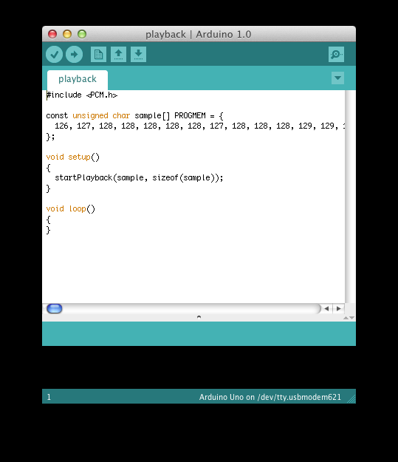

**Figure 5.0 Arduino Coding Scheme**

Source: http://highlowtech.org/?p=1963

All Arduino boards are completely open-source, empowering users to build them independently and eventually adapt them to their particular needs. The software, too, is open-source, and it is growing through the contributions of users worldwide.

Over the years Arduino has been the brain of thousands of projects, from everyday objects to complex scientific instruments. A worldwide community of makers - students, hobbyists, artists, programmers, and professionals - has gathered around this open-source platform, their contributions have added up to an incredible amount of accessible knowledge that can be of great help to novices and experts alike.

Proteus in the other hand is another example of Design the PCB board like DesignSpark and this software is not fully freeware. Figure 5.1 is example of Proteus software design the traffic light with the help of Arduino.

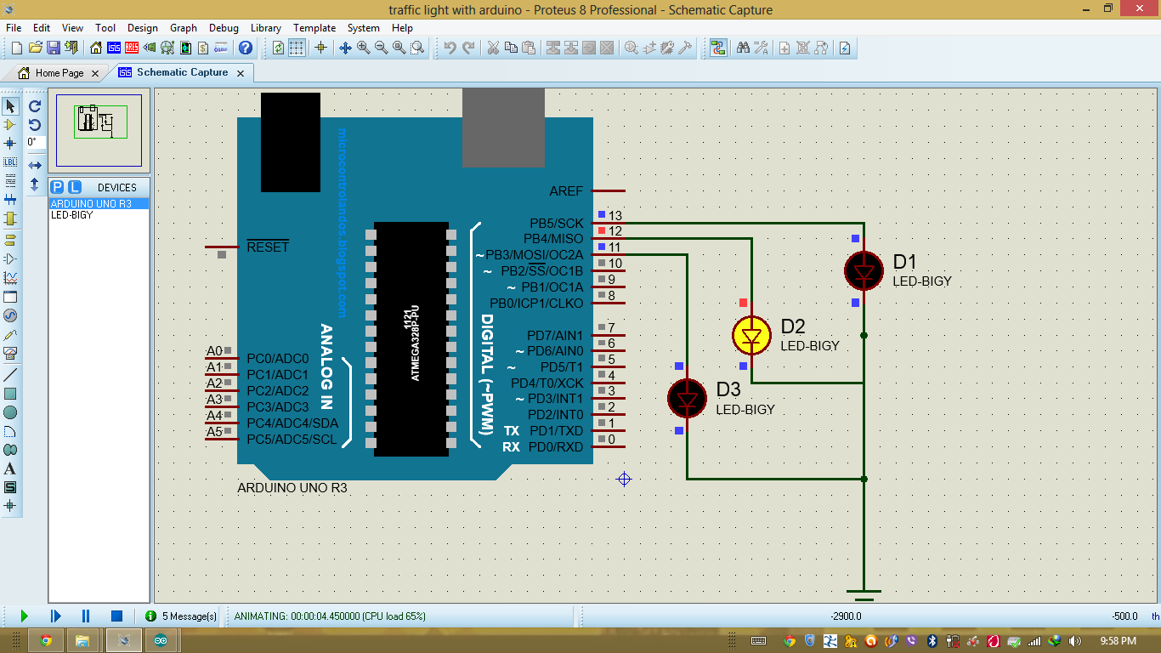

**Figure 5.1 Proteus Software**

Source: https://circuitsnepal.blogspot.com/2015/09/interfacing-lcd-with-arduino-in-proteus.html

**5.3.2 Schematics**

A schematic diagram is a picture that represents the components of a process, device, or other object using abstract, often standardized symbols and lines. Schematic diagrams only depict the significant components of a system, though some details in the diagram may also be exaggerated or introduced to facilitate the understanding of the system.

Schematic diagrams do not include details that are not necessary for comprehending the information that the diagram was intended to convey. For example, in a schematic diagram depicting an electrical circuit, you can see how the wires and components are connected together, but not photographs of the circuit itself.

Schematic diagrams are typically associated with electrical circuits. Also called wiring diagrams or circuit diagrams, these diagrams show how the different components of a circuit are connected. In these diagrams, lines represent connecting wires, while other elements like resistors, lamps, and switches are represented by standardized symbols called electrical schematic symbols.

In electronics, having a schematic diagram on hand may help a user design an entire circuit before building it, or troubleshoot an electronic that has stopped working.

Schematic diagrams may also be used to explain the general way that an electronic function without detailing the hardware or software used in the actual electronic. For example, to explain how a computer projects the words you type on a screen, you might use a schematic diagram that shows how information passes from the keys you press to a word processing program, and finally to the computer screen.

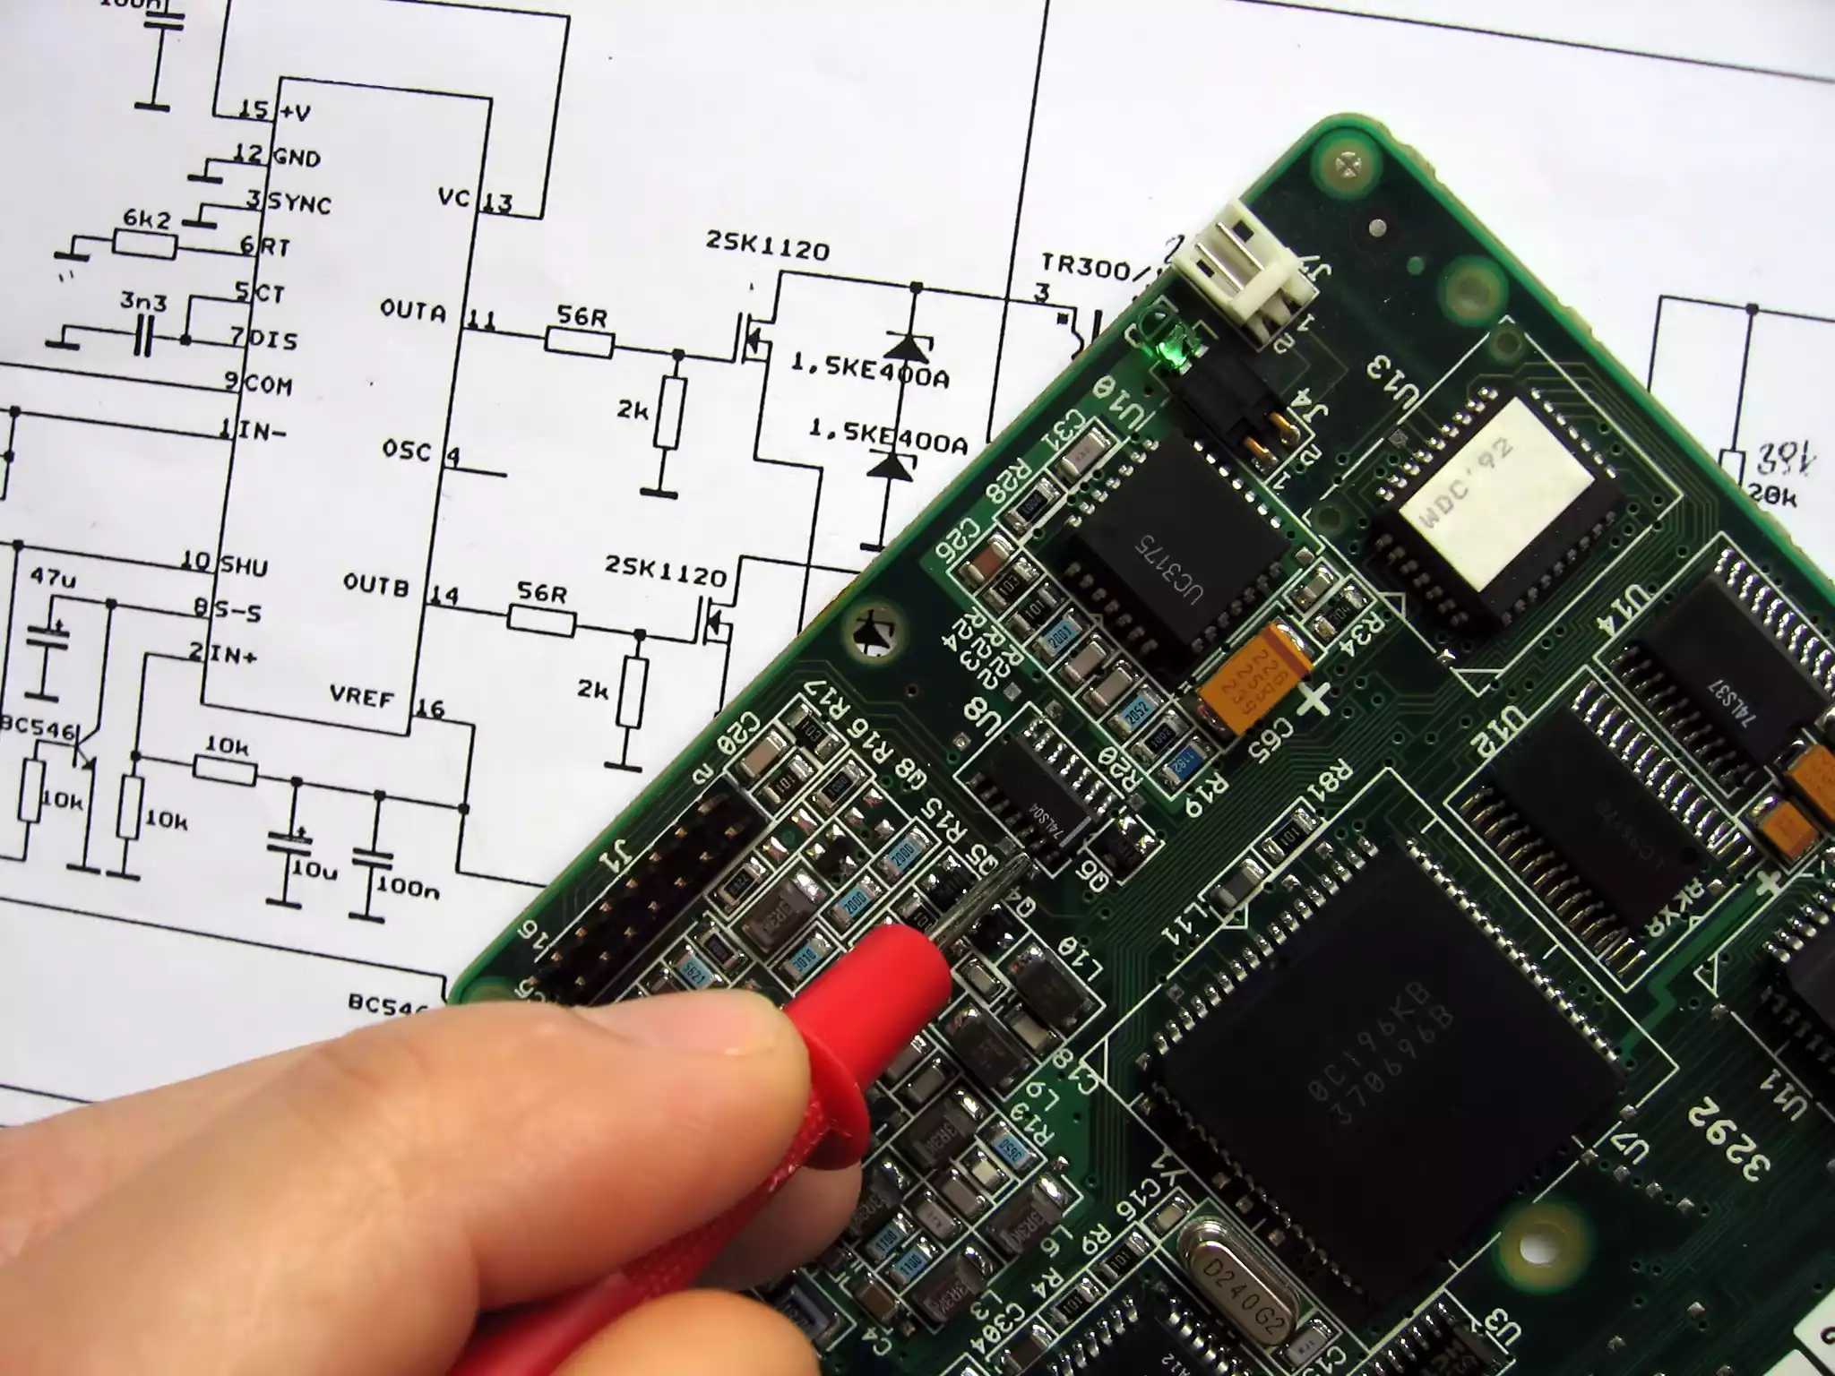

**Figure 5.2 A circuit diagram behind a circuit board**

Source: https://www.thoughtco.com/what-is-a-schematic-diagram-4584811

**5.3.3 Library**

There are various types of PCB libraries and methodologies out there, and selecting which to implement into your design process depends on a number of factors. While some small business users may require only a bare essential yet the extremely flexible representation of components, enterprise users may require a highly specific read-only representation with links to the supply chain.

In short, PCB design will save your time in case you just to lazy to create one on Arduino or DesignSpark. Library Loader is one of the most popular search tools for nowadays invention on PCB Design.



**Figure 5.3 SamacSys Library Loader**

**5.3.4 Problem Occur**

Every project done there are must be a sneaky problem occur for example, the cost to do the project, poor quality project stuff, not enough equipment’s, programming error or broken equipment.

All of this already been planned how to overcome it but some of it still maze since the project is half-way done. The cost for this project already been setup since the ESP8266-12E is cheaper than the other equipment to use is not that cost enough. The total round off for this project just around under 20 MYR or even lesser.

Poor quality project stuff occurred when the designer makes some careless mistake when doing their project. Hence, they should be responsible for any project lost on their own and have to be careful when do their project.

Not enough equipment is the major problem for this project since some project need some rare stuff to do for example soldering. Thus, there are some project that need some expensive equipment for their project to be done. Shortly, the designer has to think carefully what kind of project they need less equipment to make ensure their own budget since there are bunch of projects that required less of money out.

Programming error is common for the programmer and will never escape this situation. Hence, in order to make the programme of your project successfully done without any problem, the programmer should do Flow Chart in order to see what they want to programme so it can easily do programming part.

Broken Equipment will be occurred if the designer does cautious when do the project. Some precaution step needs to take serious in order to make the equipment been use wisely so the project can be run without any much problem.

**5.3.5 PCBWay**

PCBWay is China Shenzhen-based manufacturer specializing in PCB prototyping, low-volume production and PCB Assembly service all under one roof. We offer quick turn PCBs at a very budgetary price. Thousands of engineers, students and hobbyists are using our PCBs for their daily work and study. PCBWay strives to be the easiest manufacturer for you to work with. PCBWay – PCB Prototype the Easy Way!



**Figure 5.4 PCBWay**

Source: http://pranavhtml.blogspot.com/2018/11/pcbway-full-feature-custom-pcb.html

**CHAPTER 6**

**CONCLUSIONS AND RECOMENDDATIONS**

**6.1 Conclusions**

The PCB board can be further re-design to fit nicely into the hardware system to give more compact and more standard application for the use of human being. In the other hand Web application can be re-design to develop more user-friendly web application that help people to use it and being the great partner for the PCB board. The server also can be re-design that using an online server that help user can control the system everywhere and every time.

No matter how you great the design of your board, the user will want it for being more useful than just a look. Well, looking is great but being useless at the same time is really unnecessary for user. Make it functioning well based on what purpose of your project and design it artfully to make it have some bonus on the project. This kind of plan will surely make the project brighter for future use of the society.

**6.2 Recommendations**

ESP8266 is not perfect, of course. Express if is still a young company in Wi-Fi chip market, and the chip hardware functions haven’t been completed, like decoding. That is why ESP8266 is not easy to be accepted by large scale brand name companies.

The weak cyber security might cause damages accidentally, and the large compensation will be resulted. Thus, vendors would not be willing to take risk. Also, the advantage of lower prize does not take effect on this market. In this industry, traditional Wi-Fi chip manufacturers, like Qualcomm, Broadcom, Marvell, MediaTek, Realtek, etc, still dominate the market.

In terms of prospect, ESP8266 still can be improved no matter in software or hardware. As to hardware chip, Express if has advanced chip, ESP32, equipped with Wi-Fi and Bluetooth. On the other hand, ESP8266 can be simplified in software. For example, some users have used Scratch to support ESP8266 in a blocky and visual way. That will help more younger users to develop with ESP8266.

**REFERENCES**

DesignSpark Support October 20. (n.d.). Adding Copper Pour to DesignSpark PCB. Retrieved from https://designspark.zendesk.com/hc/en-us/articles/212026929-Adding-Copper- Pour-to-DesignSpark-PCB.

ESP-12S - RF SOLUTIONS - PCB Footprint & Symbol Download. (n.d.). Retrieved from https://componentsearchengine.com/part.php?partID=1089094&p=1.

ESP8266. (2019, October 22). Retrieved from https://en.wikipedia.org/wiki/ESP8266.

George. (2014, June 23). Introduction to Digital Multimeters. Retrieved from https://www.circuitspecialists.com/blog/introduction-to-digital-multimeters/.

Happy Bison. (n.d.). Retrieved from https://www.happybison.com/reviews/esp8266-based- esp-modules-10/.

Hasanudin, A. H. (n.d.). Controlling Lights Using A Wireless Network. CONTROLLING LIGHTS USING A WIRELESS NETWORK (pp. 1–48).

Instructables. (2017, November 15). Soldering 101: Lesson 1: Tin the Tip. Retrieved from https://www.instructables.com/id/Soldering-101%3a-Lesson-1%3a-Tin-the-Tip/.

Marriott, B., & Pcb. (n.d.). DesignSpark PCB Basic Course: Familiarisation (Part 1). Retrieved from https://designspark.zendesk.com/hc/en-us/articles/360000444074- DesignSpark-PCB-Basic-Course-Familiarisation-Part-1-.

module-family [ESP8266 Support WIKI]. (n.d.). Retrieved from https://www.esp8266.com/wiki/doku.php?id=esp8266-module-family.

Othman, A. (n.d.). Engineering Workshop Manual 2. Engineering Workshop Manual 2 (pp. 1–12).

Pcb. (n.d.). DesignSpark PCB Basic Course: Libraries (Part 2). Retrieved from https://designspark.zendesk.com/hc/en-us/articles/360000434633-DesignSpark-PCB- Basic-Course-Libraries-Part-2-.

Pcb. (n.d.). DesignSpark PCB Basic Course: Creating Components (Part 3). Retrieved from https://designspark.zendesk.com/hc/en-us/articles/360000434673-DesignSpark-PCB- Basic-Course-Creating-Components-Part-3-.

Pcb. (n.d.). DesignSpark PCB Basic Course: Schematics (Part 5). Retrieved from https://designspark.zendesk.com/hc/en-us/articles/360000435793-DesignSpark-PCB- Basic-Course-Schematics-Part-5-.

Pcb. (n.d.). DesignSpark PCB Basic Course: Translate to PCB (Part 6). Retrieved from https://designspark.zendesk.com/hc/en-us/articles/360000435893-DesignSpark-PCB- Basic-Course-Translate-to-PCB-Part-6-.

Pcb. (n.d.). DesignSpark PCB Basic Course: Exporting (Part 7). Retrieved from https://designspark.zendesk.com/hc/en-us/articles/360000435933-DesignSpark-PCB- Basic-Course-Exporting-Part-7-.

Simple Arduino audio samples. (2018, November 6). Retrieved from http://highlowtech.org/?p=1963.

Sinovich, A., Pcb, & Pcb. (n.d.). How do I use PCB Part Library with Library Loader? Retrieved from https://designspark.zendesk.com/hc/en-us/articles/115004510445- How-do-I-use-PCB-Part-Library-with-Library-Loader-.

TechDesign. (2019, September 3). 8 Reasons Why ESP8266 has Been So Popular. Retrieved from https://blog.techdesign.com/8-reasons-esp8266-popular/.

What are the differences between solder mask and paste mask? (n.d.). Retrieved from https://www.allpcb.com/soldermask/solder_mask_paste_mask.html.

What is a Printed Circuit Board? Make Circuits by Connecting Components. (n.d.). Retrieved from https://www.altium.com/solution/what-is-a-pcb/.